WS 7-1 Name:_________________________________
Date:___________________ Class:________

Classify the triangle by its angles and by its sides.
1. 2. 3.
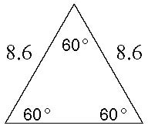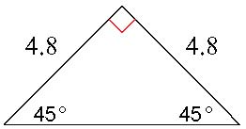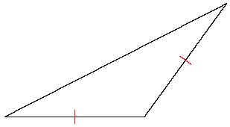
8.6

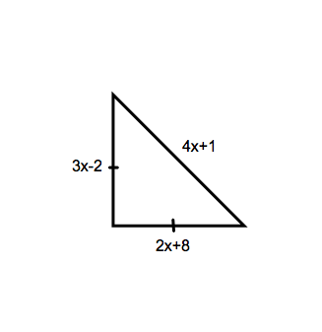
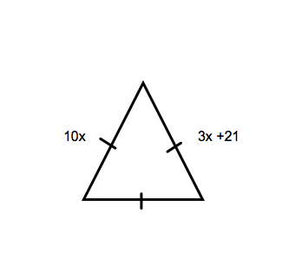

Find x.
4. 5.

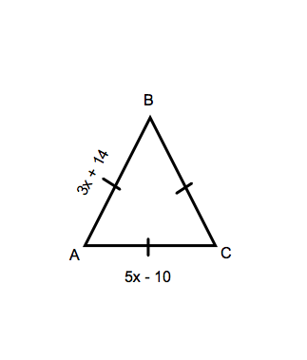
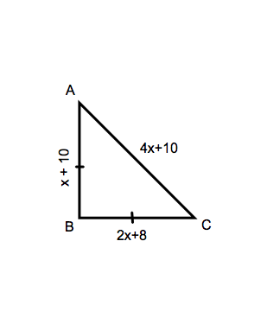
Find the lengths of the sides of the triangle. (hint: Solve for x, then plug x into each side to find their lengths)

6. 7.

Determine if the triangle is Equilateral, Isosceles, or Scalene.
8. Find the measures of the sides of KPL and classify each triangle by its sides
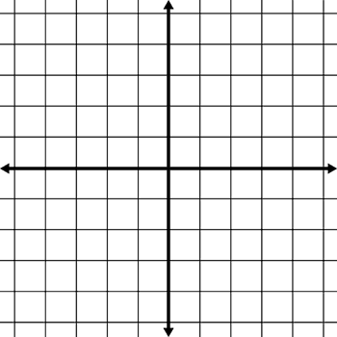
K( 3, 2) P(2, 1), L( 2, 3)

