Name: _______________________ Date: ___________ Period: ________

WS 6-1 (section 7.1)

Solving Linear Systems by Graphing

- What does it mean to solve a system of linear equations?

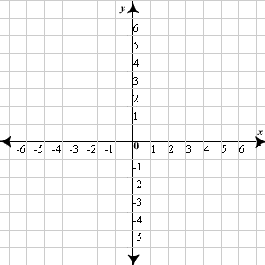
- Graph the linear system below. Then circle the ordered pair if it is a solution of the system.

-x + y = -2
2x + y = 10

- (-4,-2) b. (4,-2) c. (-4,2) d. (4,2)

- Confirm your answer for Exercise 2 algebraically.

Use the graph-and-check method to solve the system of linear equations.

- y = 2x – 1
y = x + 1

- y = -2x + 3
y = x – 3

- y = 1/2x + 2
y = -x + 5

- 5x + 4y = 16
y = -1

- x – y = 1
5x – y = 0

