Name: ___________________________ Date: ___________ Period: ________

WS 5-1

Writing Linear Equations

Write the slope-intercept form of the equation of the line

1) 3x − 2y = −16 2) 13x – 11y = -12

3) 9x – 7y = -7 4) x – 3y = 6

5) 6x + 5y = -15 6) 4x – y = 1

7) 11x – 4y = 32 8) 11x – 8y = -48

Write an equation of the line shown in the graph
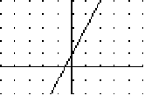
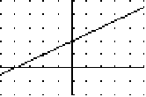
10)
9)

y = y =

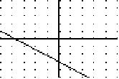
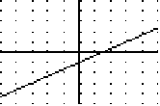
11) 12)

y = y =

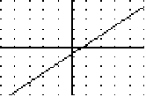
13) 14)

y = y =

