Name: ___________________________ Date: ___________ Period: ________

WS 4-5
Graphs and Solving Equations
SHOW ALL YOUR WORK TO RECEIVE FULL CREDIT

I. Slope and Intercepts

1. Find the slope and y-intercept of the equation $y=\frac{1}{3}x+2$ .

2. Find the slope and y-intercept of the equation $2x-y=4$ .

II. Slope-Intercept Form

3. Write the equation in slope-intercept form, then graph $4x-2y=6$ . 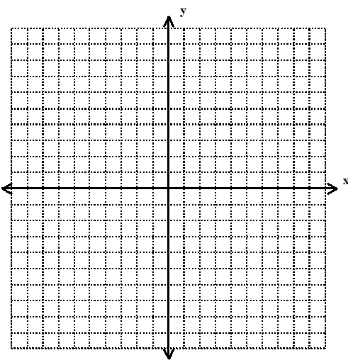

4. Are the two equations parallel? Why or why not?
$y=4x-1$ $y=4x+7$

III. Solving Linear Functions

5. Write the one-variable equation as a related function.

a. $2x-4=5$ b. $\frac{1}{4}x+2=1$ c. $4x-2=3x+5$

IV. Solving Graphically

6. Solve $\frac{2}{3}x+5=11$ graphically. Check your solution algebraically.

V. Solving Algebraically

7. Solve $4x-1=7$ algebraically. Check your solution graphically.

