Name: ___________________________ Date: ___________ Period: ________

WS 4-2

Functions and Relations
SHOW ALL YOUR WORK TO RECEIVE FULL CREDIT

I. Domain and Range

1. What is the domain of the function? -1 0
1 2
4 3
5 6

2. What is the range of the above function?

3. What is the domain of the function? (2, 0), (3, -4), (0, 1), (1, 1)

4. What is the range of the function? (2, 0), (3, -4), (0, 1), (1, 1)

5. Is this a function? Why or why not?
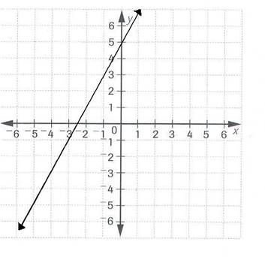

II. Evaluating Functions

6. Evaluate $f\left(x\right)=3x-2$ when $x=3$.

7. Evaluate $f\left(x\right)=x^{2}+6$ when $x=-2$.

III. Graphing Linear Functions

8. Graph the function.

$f(x)=\frac{1}{2}x-1$ $f\left(x\right)=3x+1$

