Name: ___________________________ Date: ___________ Period: ________

WS 4-1

Coordinates and Scatter Plots

I. Scatter Plots

1. Plot and label the points on the coordinate plane:

(1, 0)  (3, 4)  (-2, 8)  (-9, -7)  (-3, -5)  (6, -6)  (-5, 3)  (2, -9)  (1, 8) | 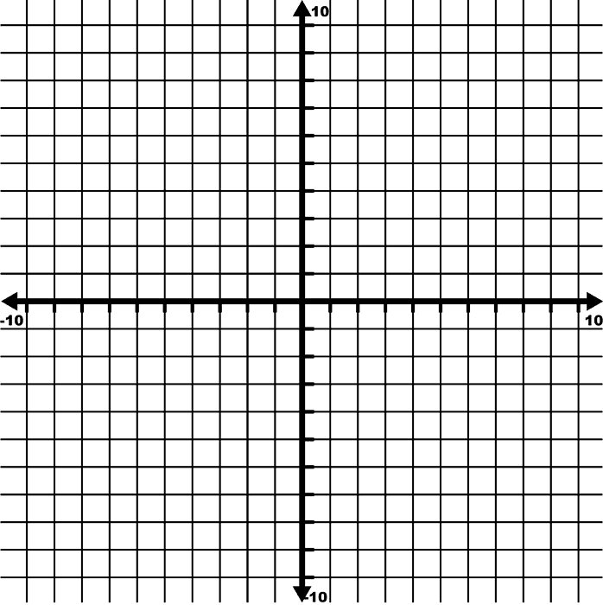

2. You are the manager of the school basketball team. You have gathered data about the players’ heights and weights in the following table.

Height (in.) | 72 | 70 | 73 | 73 | 75
Weight (lb.) | 175 | 160 | 180 | 185 | 190

a. Make a scatter plot of the data. Put height h on the horizontal axis and weight w on the vertical axis. Be sure to label your axes!

b. Use the scatter plot to estimate the weight of a player who is 76 inches tall.

II. Describing Patterns

2. The amount of money (in millions of dollars) spent in the United States on snowmobiles is shown in the table.

Year | 1990 | 1991 | 1992 | 1993 | 1994 | 1995 | 1996
Snowmobiles | 322 | 362 | 391 | 515 | 715 | 924 | 970

a. Draw a scatter plot on the coordinate plane. Because you want to see how spending changes over time, put time t on the horizontal axis and spending s on the vertical axis.

b. Describe the pattern of the amount of money spent on snowmobiles.

