Name: ___________________________ Date: ___________ Period: ________

WS 12-3

Correlation and Best-fitting Lines

State whether the following scatter plots reflect a linear or non-linear relationship and state whether they have a positive, negative or no correlation.

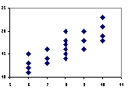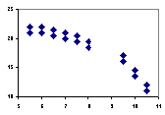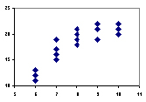

1. ______________________ 2. _____________________ 3,. ___________________
.
______________________ _____________________ ___________________

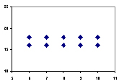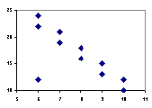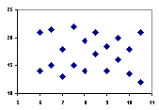

4. _________________________ 5. ________________________ 6. _______________________

_________________________ ________________________ _______________________

3. For each of the following pairs of variables, indicate whether you would expect a positive correlation, a negative correlation or a correlation close to 0. Explain your choice.

a. Maximum daily temperature and cooling costs.

b. Incomes of husbands and wives when both have full time jobs.

c. Height and IQ

d. Height and shoe size

Activity 1

Background: It is hypothesized that the length of your forearm and then length of your feet are equivalent. We will test the hypothesis.

1. Using a ruler measure the length of your forearm and the length of your foot. When you have your measurements record them on the table below and the class table on the board.
Forearm Length | Foot Length

Record the class data in the table to the left.

Let x represent the forearm length and let y represent the foot length. To begin, plot the points given by the ordered pairs. Then sketch the line that appears to best fit the points
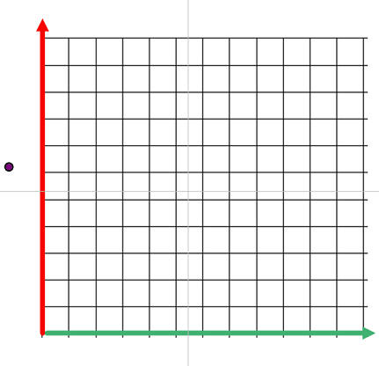

2. Find two points that lie on the line and find the slope of the line through these two points.

3. To find the y-intercept of the line, substitute the values you found for m and a point (x,y) in the slope intercept form y = mx + b.

4. Write the equation for the best- fitting line.

5. Predict the forearm size for someone with 23 cm long foot.

6. Describe the correlation between forearm size and foot size.

