Secondary II Name: ________________________________

Unit 8 Review Period: ________

*Identify the vertex and the axis of symmetry:*

1.  2. 

*Put the following in vertex form; identify the vertex, axis of symmetry then describe all transformations.*

3.  4. 

5.  6. 

7.  8. 

*Sketch each graph by hand.*

9.  10.  11. 

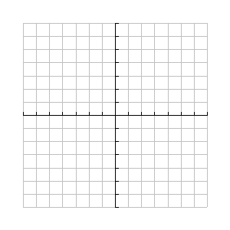

12.  13.  14. 



Identify the focus, directrix and focal length of the following:

15.  16. 

Write the equation of the parabola give the focus and directrix:

17. Focus: (3, 8) Directrix: y =4 18. Focus: (0,0) Directrix: y = 1

19. Focus: (2, 5) Directrix: y =3 20. Focus:  Directrix: 