Secondary II Name: ________________________________

Unit 6 Review Period: ________

**Factor the following:**

1.  2.  3. 

4.  5.  6. 

7.  8. 

9.  10.  11. 

**What constant must be added to the polynomial to make it a perfect square?**

12.  13. 

**Simplify each polynomial expression.**

14.  15. 

16.  17. 

18.  19. 

20.  21. 

**Label as Cubic, Quadratic, Linear, or None.**

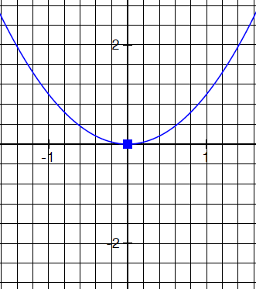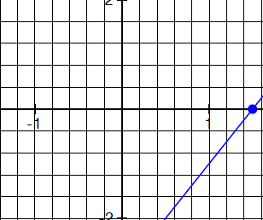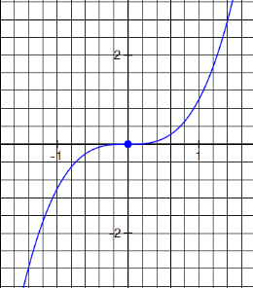22. 23. 24.

**Write an equation in graphing form for the following graphs.**

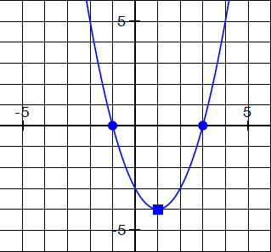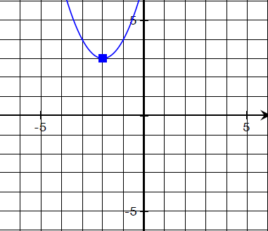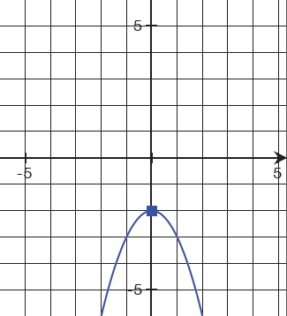25. 26. 27.

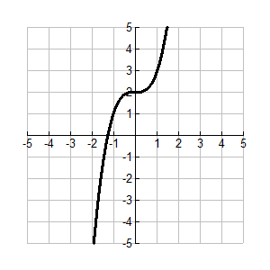_______________________________ _______________________________ _______________________________

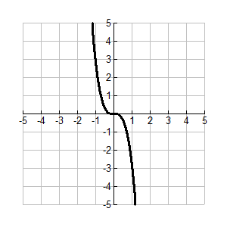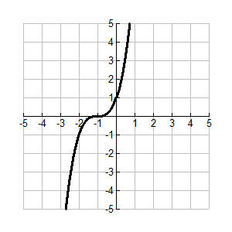

28. 29. 30.

_______________________________ _______________________________ _______________________________

**Label as Even, Odd, or Neither**

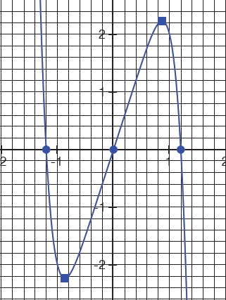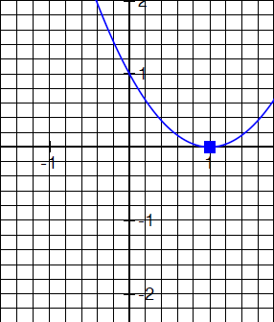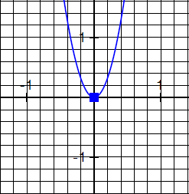

31. 32. 33.