SECONDARY MATH II NAME _____________________________________

UNIT 5 REVIEW PERIOD ______

1. What does SOH-CAH-TOA stand for?

**Find all trigonometric functions for .**

2. 3.

5 



3 3



4 3

**Evaluate using a calculator. Round to 3 decimal places.**

4. sin 42° 5. cos 82° 6. tan 29° 7. sin 7°

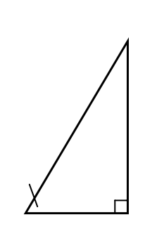**Set up and use trigonometric ratios to find the missing values.**

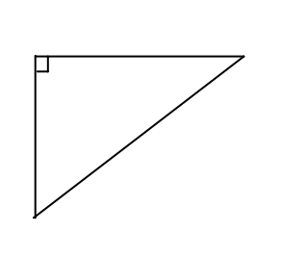8. 9.

12 in



x

x



15 ft

**Find the missing side length.**

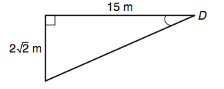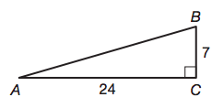

9. 10.

**Draw a triangle and find all other trigonometric functions for problems.**

11.  12. 

**Find the missing side lengths for each special triangle.**

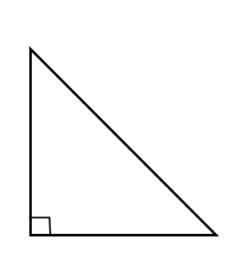

3

x

y

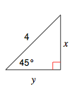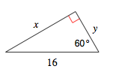

13.  14. 15.

300

16. Find the value of x.

x

250

8

**Using a calculator, find each anglemeasure to the nearest degree.**

17.  18.  19. 

**Find the measure of the indicated angle to the nearest degree.**



7

12



14

17

x

20. 21.

x

**Solve the right triangles.**

C

B

*c*

13

6

A

22. 23.

P

*p*

Q

R

*r*



11



   

24.

A ladder 5 m long, leaning against a vertical wall makes an angle of 65˚ with the ground.

a) How high on the wall does the ladder reach?

b) How far is the foot of the ladder from the wall?

c) What angle does the ladder make with the wall?