Secondary Math II Name:_________________________________

UNIT 4 REVIEW Period:_________

1. Define Preimage:

2. Define Image:

3. Define Dilation:

4. If  , then

a)  = b) = c)  = d) 4a =

5. Find the scale factor: _________

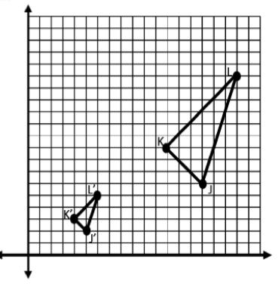

6. Quadrilateral ABCD has coordinates A: (2,2) B: (4,2) C: (2,6) D: (6,8).

1. What are the vertices of image EFGH after a dilation with a scale factor of 3, using the origin as the center of dilation?
2. What are the vertices of the image JKLM after a dilation with a scale factor of 1/2, using the origin as the center of dilation?

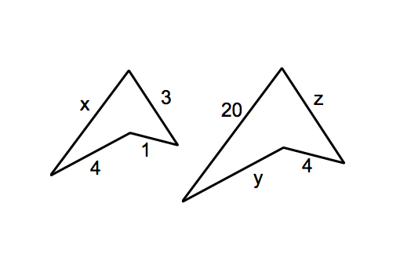

7. Solve the variables using the similar figures below.

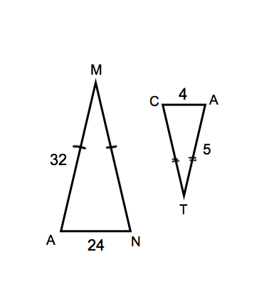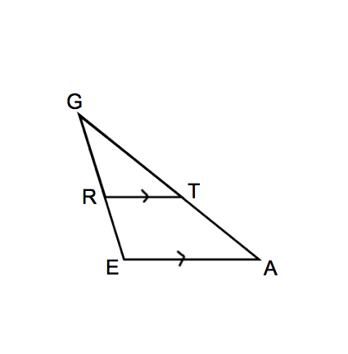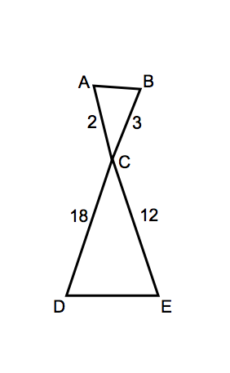Which theorem can be used to state these two triangles are similar? If using proportional sides, be sure to show they are proportional. Then complete the similarity statement.

8. 9. 10.

~ ~ ~

11. What TWO characteristics make a segment a midsegment of a triangle?

1-

2-

D

A

B

C

12. In the figure, DC=18, AC=40 and AB=25. Find AD.

13. Given that AC||DE, AD = x+1, BD =3, 14. Given that d = 3, e = x + 4, and

BE = 5 and EC = 2x - 4, solve for x. g = 2x – 2, f = 4 find x.

B

D

A

E

C

*f*

*g*

*e*

*d*

15. Find the geometric mean between 3 and 18. 16. 6 is the geometric mean of 13 and _______

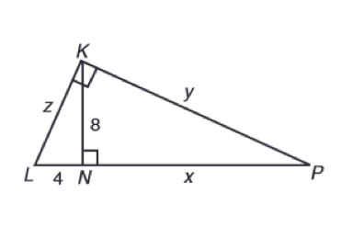

17. Find the values of the variables.

18. You are trying to estimate the height of the school’s flagpole. You stand so the tip of the flagpoles shadow and the tip of your shadow meet. The length of the flagpoles shadow is 10 feet and the length of your shadow is 2 feet. You are 5 feet tall. Draw a diagram and determine the height of the flagpole.

19. You are visiting the coast and come to a lighthouse. You want to estimate its height. You put a small mirror on the ground 10 feet from the lighthouse. You have your little sister walk 2 feet away from the mirror to see the top. Your sister’s eyes are 4 feet from the ground. Draw a diagram. To the nearest foot, how tall is the lighthouse?