SECONDARY MATH II NAME _____________________________________
UNIT 3 REVIEW PERIOD _________

Define the following terms
- Supplementary angles:

- Complementary angles:

- Vertical angles:

- Linear pair

- Adjacent angles

- Write the following quadrilaterals in the appropriate place in the venn diagram: quadrilaterals, parallelograms, rectangles, squares and rhombi.
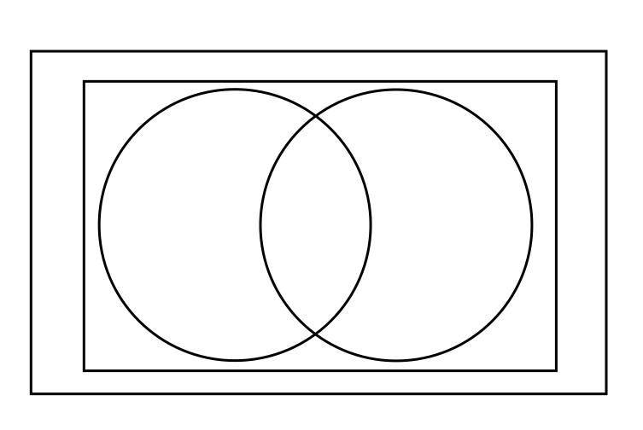

  - Describe the characteristics of each quadrilateral listed above.

Decide whether the statement is sometimes, always, or never true.
- A rhombus is equilateral.
- The diagonals of a rectangle are perpendicular.
- The opposite angles of a rhombus are supplementary.
- The diagonals of a rectangle bisect each other.
- The consecutive angles of a square are supplementary
Identify each special quadrilateral. Use the most specific name.
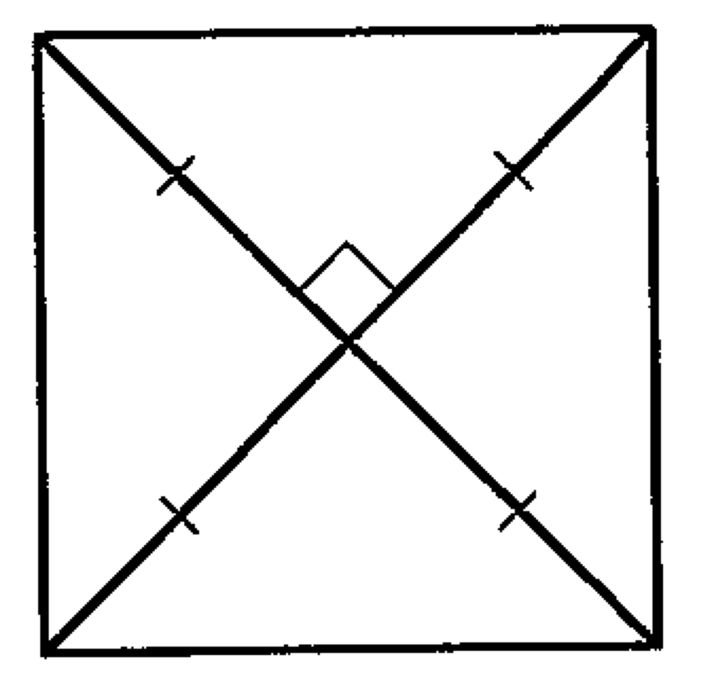
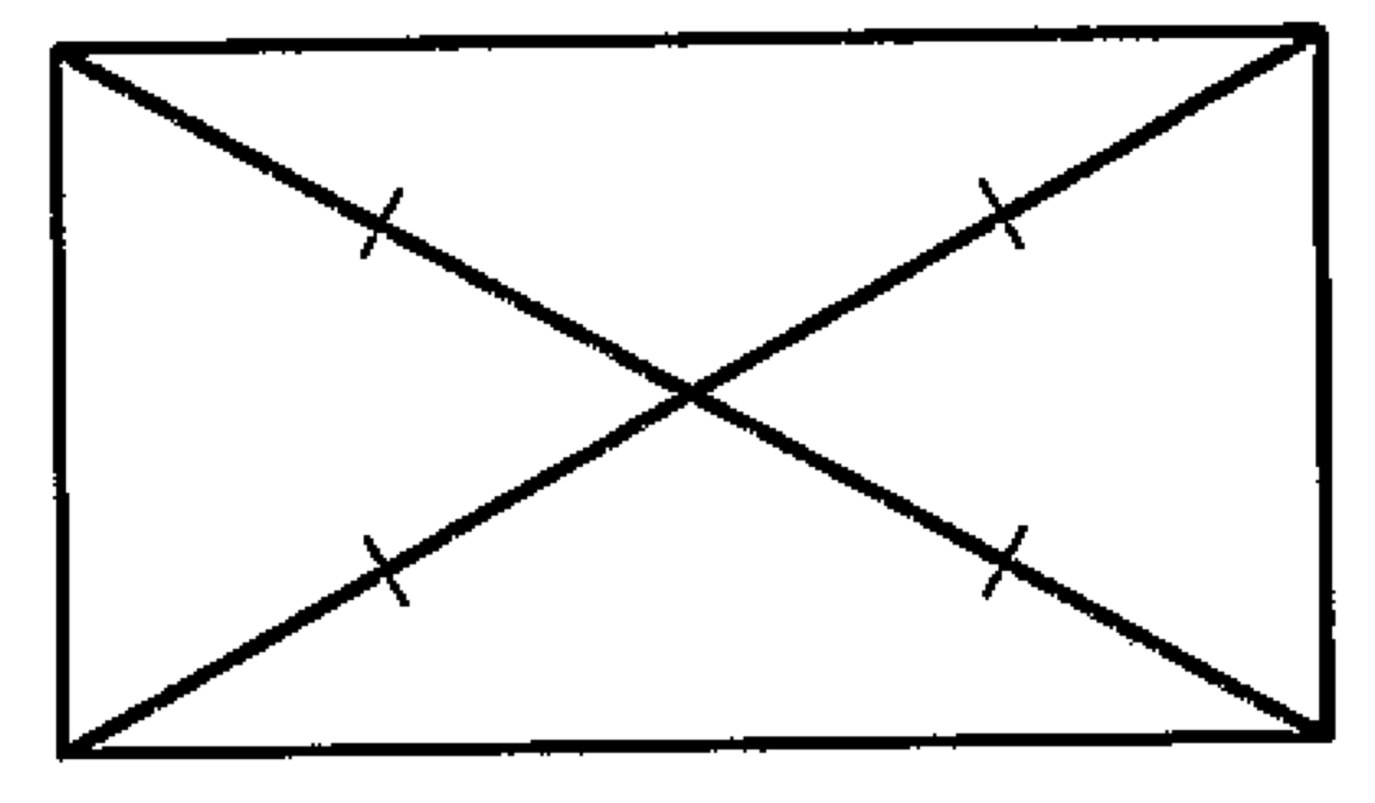
- 13.

Find the value for each variable in the parallelogram.
14. MNOP is a square. 15.
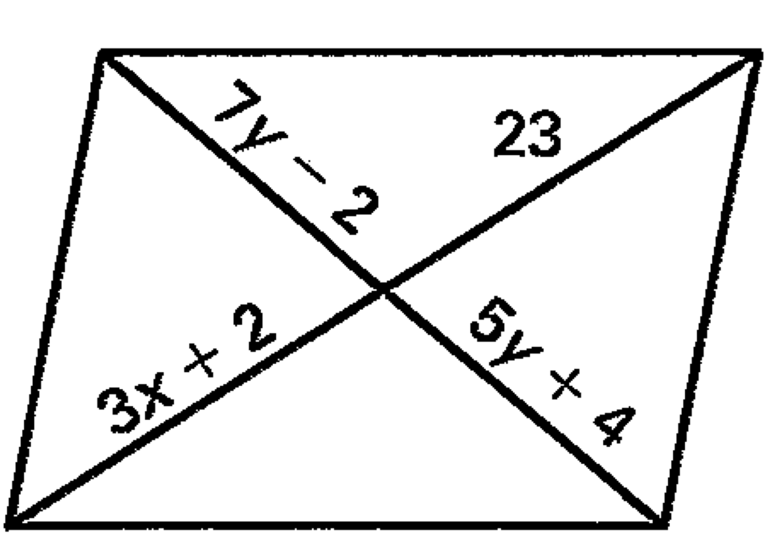
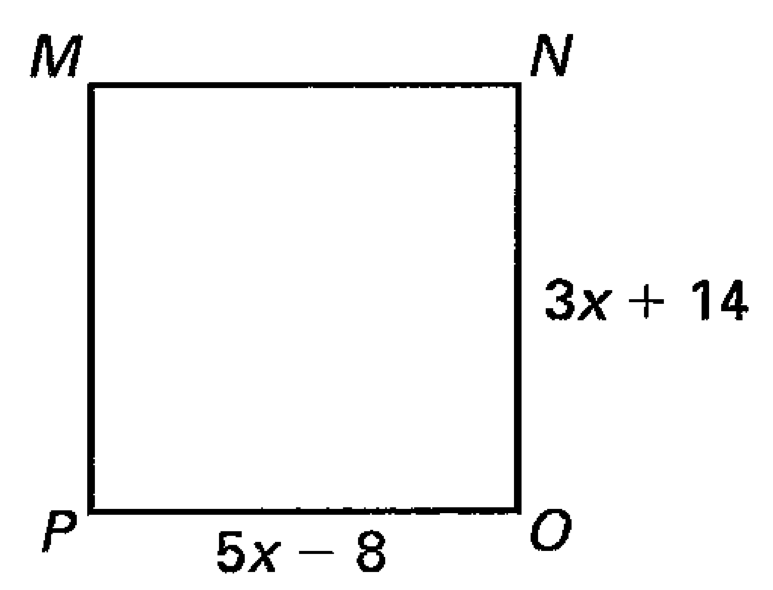

- In the figure, line x is parallel to line y and $m∠1=64°$. Determine the measure of each angle.

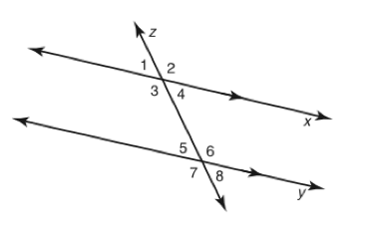
$m∠1=_________$
$$m∠2=_________$$
$$m∠3=_________$$
$$m∠4=_________$$
$$m∠5=_________$$
$$m∠6=_________$$
$$m∠7=_________$$
$$m∠8=_________$$

- In the figure above list a pair of angles for the following terms:
  - Alternate interior angles:
  - Alternate exterior angles:
  - Corresponding angles:
  - Vertical angles:

Find the value of x.

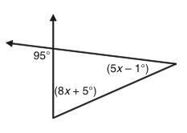
18. 19. 20.
