Secondary Math II Name:_________________________________________

Unit 13 review Period:_____________

Write the standard form of the equation of each circle whose information is given.

1. Center: (1, -3) 2. Center: (3, 0)

Radius: 4 Radius: 

Graph each given the standard form of the equation.

3.  4. 

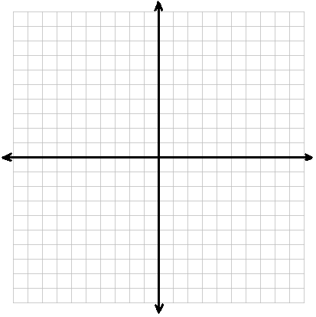

Find the radius…

1. of a circle with the diameter of 12
2. of a circle with the circumference of 
3. of a circle with an area of 

Find the Arc Length of the circle.

a. θ = , r = 12 in. b. θ = , r = 7 m. c. θ = , r = 24 in.

Find the volume of each figure.

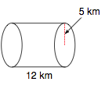

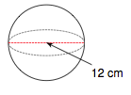

**Find the indicated measure:**

Length of Circumference Radius





**Find the area of the shaded region. Round answer to the nearest tenth. Don’t forget units!!!**

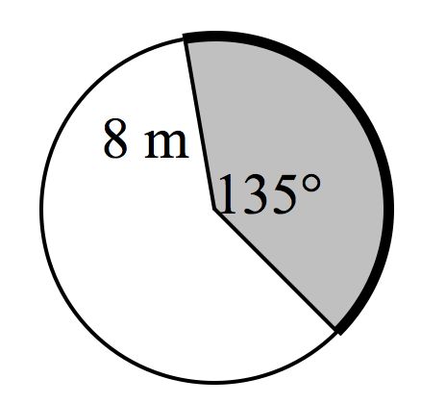

Put the equation in standard form

