Secondary Math II Name:_________________________________________

Unit 11 Review Period:___________

**Evaluate:**

1.  for x = -1 2. for x = -1/2 3.  for x = -2

4. , find j(1/3) 5. , find k(-7) 6. , find *l*(2)

**Find  and  for each of the following:**

7.  8.  9. 

**Find  and . Are the functions inverses?**

10.  11.  12. 

**Write the domain and range of the function. Then write the inverse of the function. Determine if the function is one-to-one.**

13.  14. 

**Write the domain and range of the function in *interval notation*. Determine if the function is one-to-one. Explain WHY or WHY NOT!**

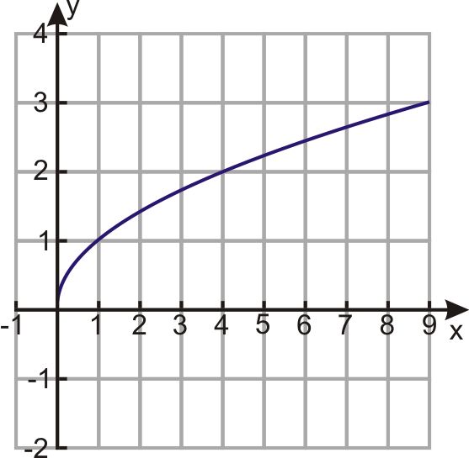15. 16. 17.

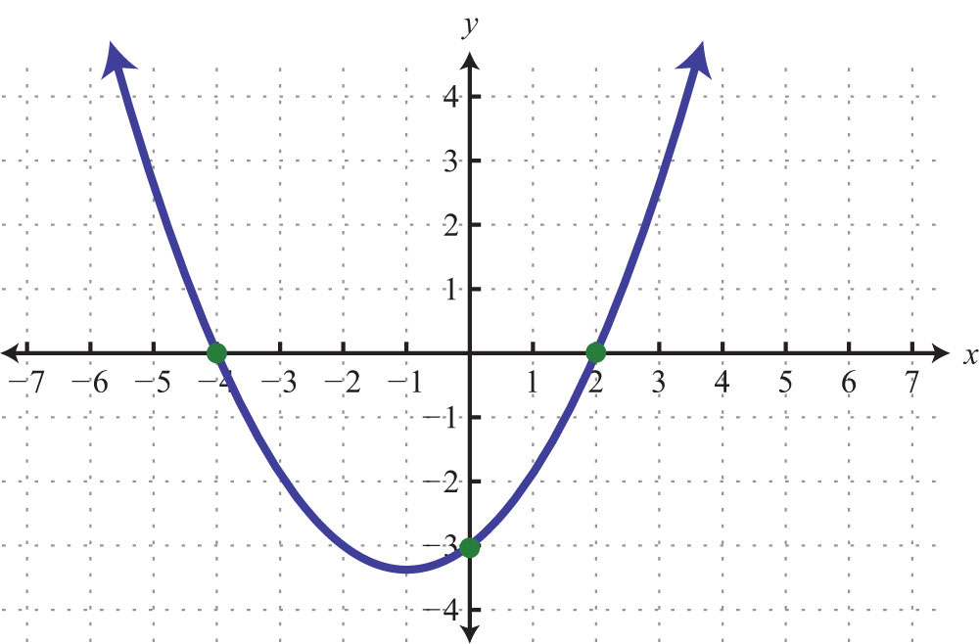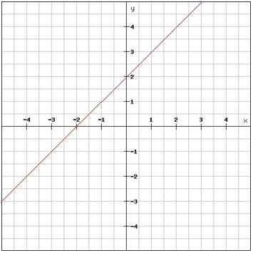

**Find the inverse of each function.**

18.  19.  20. 

**Find the inverse of each function. Then verify, using composition that they are inverses of each other.**

21.  22. 

**Write the function from the given graph:**

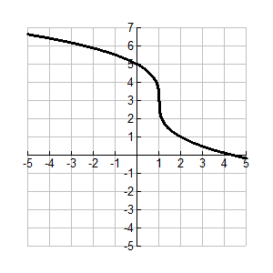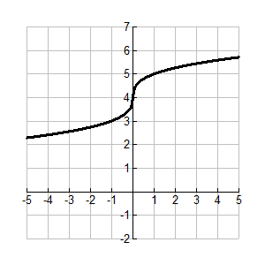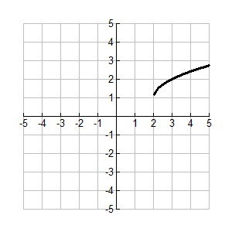

23. 24. 25.

**Sketch the graph of the given function:**

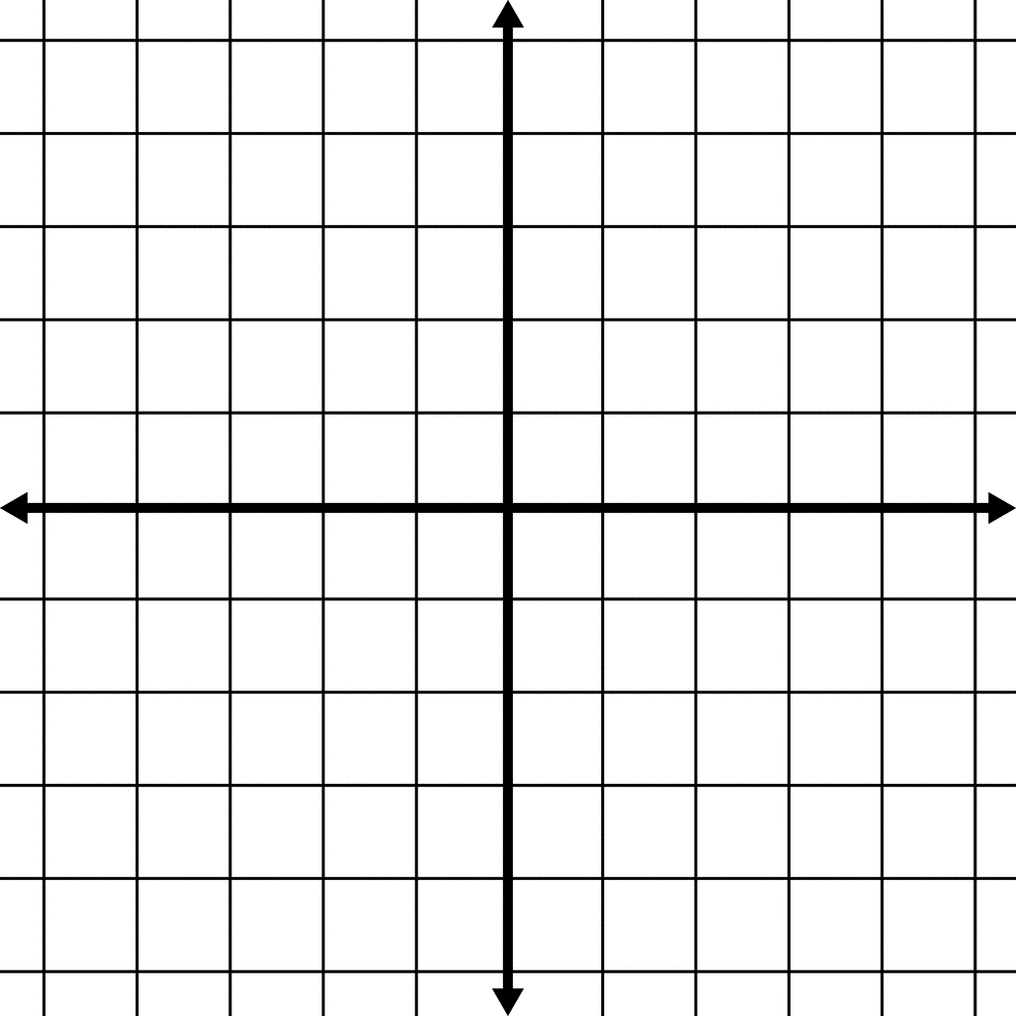26.  27.  28. 