Review Test 4 Name_____________________________________
Algebra I Date_____________________Period____________

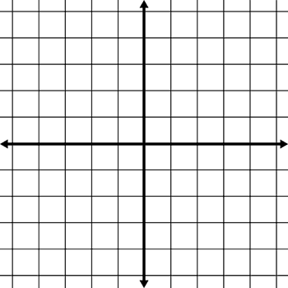
1. Graph and label the following points:

(2, 4), (3, 1), (-2, 0)

2. Label the quadrants of the coordinate plane.

3. Find the domain and range of the relation.

(1, 0), (-4, 8), (-2, -3), (1, 5)

Domain:
Range:

4. Is the given relation a function? Why or why not?

(1, 0), (-4, 8), (-2, -3), (1, 5)

5. Find the slope between the points (1, 2) and (4, 1).

6. What does a linear relation look like?

7. Is (-2, 6) a solution to $=3x+12$ ?

8. What is the slope of $=-2x+1$ ? What is the y-intercept?

9. What is the slope of $3y-2x=6$ ? What is the y-intercept?

10. Horizontal lines have _________________ slope.

Vertical lines have ________________ slope.

11. What is the slope of a line that is parallel to $=4x-1$ ?

12. To write an equation in function notation, we change the y to what?

13. What is the function notation for $=3x+7$ ?

14. What is the function notation for $2x-y=-1$ ?

15. What is the x-intercept of $3x+y=5$ ? What is the y-intercept?

16. What is the x-intercept of $6x-3y=-1$ ? What is the y-intercept?

17. Graph the line on the coordinate plane.

$y=-x+2$

18. Is the line in 17 a function? Why or why not?

19. Rewrite the equation in slope-intercept form: $3x-5y=1$

20. Write the equation of a line that has a slope of $-\frac{1}{2}$ and a y-intercept of 5.

21. Graph the line with a slope of $-\frac{1}{2}$ and a y-intercept of 3.

23. Is the relation a function?

-1 0 1 2 4 3 5 6

22. Solve the relation graphically.
$y=x-3$

24. Is the relation a function?

