Review Day 3 Worksheet
Name: __________________________________________ Period: ____________
Directions: Indicate whether the following representations are linear, exponential, or neither on the line provided. Provide a justification for each answer.
- 3, 6, 9, 12… ______________________________________
Justification:

- 180, 160, 140, 120… ______________________________________
Justification:

- 8, 16, 32, 64, 128… ______________________________________
Justification:

0 | 100  ______________________________________  Justification:
1 | 150
2 | 200
3 | 250
4 | 300
5 | 350

5.
0 | 50  ______________________________________  Justification:
1 | 25
2 | 12.5
3 | 6.25
4 | 3.125
5 | 1.5625

6.
0 | 19  ______________________________________  Justification:
1 | 15
2 | 11
3 | 7
5 | -1
7 | -9

7. A plumber charges a fee of $80 to come out to your house plus an additional $45 an hour

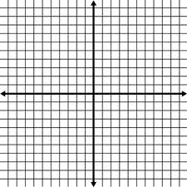
8-10. Choose 3 of the problems from # 1 –7 and create an equation and sketch a graph for each of them.
a.

b.

c.

