Review Day 3 Homework
Name: _____________________________________ Period: ____________

Linear, Exponential, or Neither

Directions: Indicate whether the following representations are linear, exponential, or neither on the line provided. Provide a justification for each answer.

- 2, 6, 18, 54, 162… ______________________________________
Justification:

- -8, -4, 0, 4, 8… ______________________________________
Justification:

- 40, 20, 10, 5, $\frac{5}{2}$… ______________________________________
Justification:
4.
0 | 0  ______________________________________  Justification:
1 | 8
2 | 18
3 | 30
4 | 44
5 | 60

5.
0 | $\frac{4}{3}$  ______________________________________  Justification:
1 | 4
2 | 12
3 | 36
4 | 108
5 | 324

6.
0 | 6  ______________________________________  Justification:
1 | 9
2 | 14
3 | 21
4 | 30
5 | 41

7. A piece of paper is cut into two equal sections. Each new piece is cut into two additional pieces of equal size. This pattern continues until it is no longer possible to cut the paper any more.

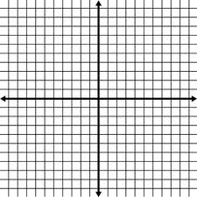
8-10. Choose 3 of the problems from # 1 – 7 and create an equation and sketch a graph for each of them.
a.

b.

c.

