Review Day 1 WS Name:_________________________________
Date:_________________ Class:__________

- Create a table and graph to represent how the perimeter is growing

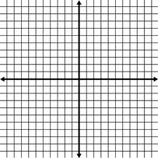
step | toothpicks

- From the information above, state the rate of change, initial value, and write a rule

- Find the slope, y-intercept, and write a rule for the following

x | y
-2 | 0
0 | 3
2 | 6
4 | 9

Slope:__________ Slope:_____________
y-intercept:___________ y-intercept: __________
Rule: Rule:

- Find the rate of change the represents the following lines
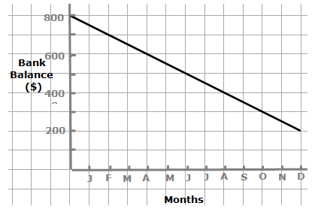
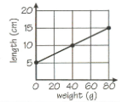

- For the following situation fill in the table of values, make a graph, and write 2 equations

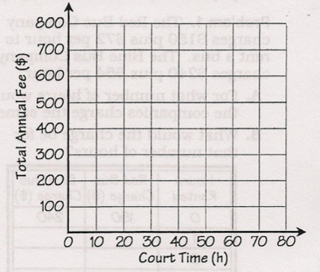
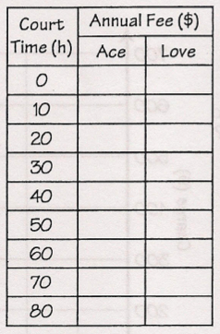
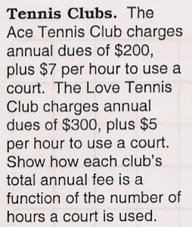

Ace Tennis Club Equation: Love Tennis Club Equation:

- At “Cross Fit” there is a startup fee of $120 and then a $35 monthly fee
  - Write an equation that represents the cost C

  - What does the slope represent?

  - What does the y-intercept represent?

  - What is the cost of a two-year membership?

Fill in the blank
- The initial value represents the _______________________
- The rate of change represents the_____________________
- The variable represents___________________________________________________

- Find the slope of the line that passes through the following points and write a rule.

  - A(-3,4) and B(0,3) Rule:

