Name: ___________________________ Date: ___________ Period: ________

# Review Day 1 HW

*Find the slope and y – intercept of the following equations*

1. . 2. . 3. 

*Write the slope-intercept equation of the line with the given information*

4) m = 7, b = 12 5) through: (2, 5), slope = undefined

6) through (4, 2), slope = 0 7) m = ½, b = 0

8) For the following situation fill in the table of values, make a graph, and write 2 equations

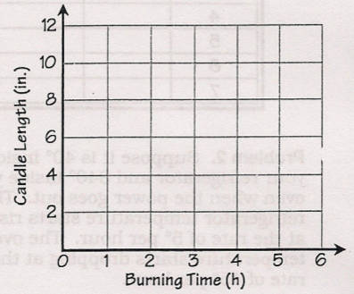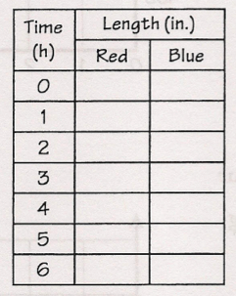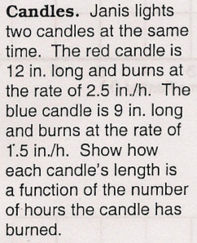

Red candle equation: Blue candle equation:

9) For Illinois residents, the average tuition at Chicago State University is $157 per credit with an initial fee of $218.

* 1. Write an equation
  2. What is the cost for a student who is taking 32 credit hours