Tessellations Project (4th Quarter)
Follow the directions below to create your tessellation. You will be graded by this rubric.
Directions:
- Start with your half-notecard (1.5x2.5)
- Using your pencil, outline a shape on the bottom side. (Step 1 below.)
- Cut out the outlined slice and translate it to the top. Tape the slice to the bottom so that there are no spaces between the slice and the side. (Step 2 below.)
- Now, using your pencil, outline a shape on the left side. (Step 3 below.)
- Cut out the outlined slice and translate it to the right side of the square. Tape the slice to the right side so that there are no spaces between the slice and the side. (Step 4 below.)
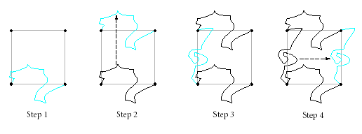
- At this point you are ready to create your tessellation. Place your created tessellation tile at the top left of your blank paper. Trace the tile onto the paper.
- Translate your tile to the left and continue to trace your tile.
- After you have filled the entire paper with tracings of the tile, you may begin to design your tile and create a picture tessellation. Be creative!

___________ (60 points) Your shape has been tessellated across the entirety of your paper. There are no empty spaces and the shape is repeated to each edge.
___________ (15 points) You have colored your tessellation neatly
___________ (20 points) Creativity
___________ (5 points) Turned in with the rubric

______________/ 100

This project is due ______________________

