Final Review Name: _____________________________________

Secondary 1 Date: ____________________ Class: __________

1. Steve has made several errors while recording entries for his checking account. His mistakes lead him to believe that he has $140 in his account, when in fact he has only $66. He writes a check for $94.
   1. How much money does he think he has left after this transaction? ________
   2. How much money does he actually have left? ________________________________

**Evaluate.**

2. a. b.  c. 0 – 5 d. -3 – (-7)



**Simplify without a calculator**:

3. 14 + 8 ÷ 2 – 1 4. 20 ÷ 5 – (6 – 3)

**Evaluate each fraction and write in lowest terms**

5. 6.

7. 8.

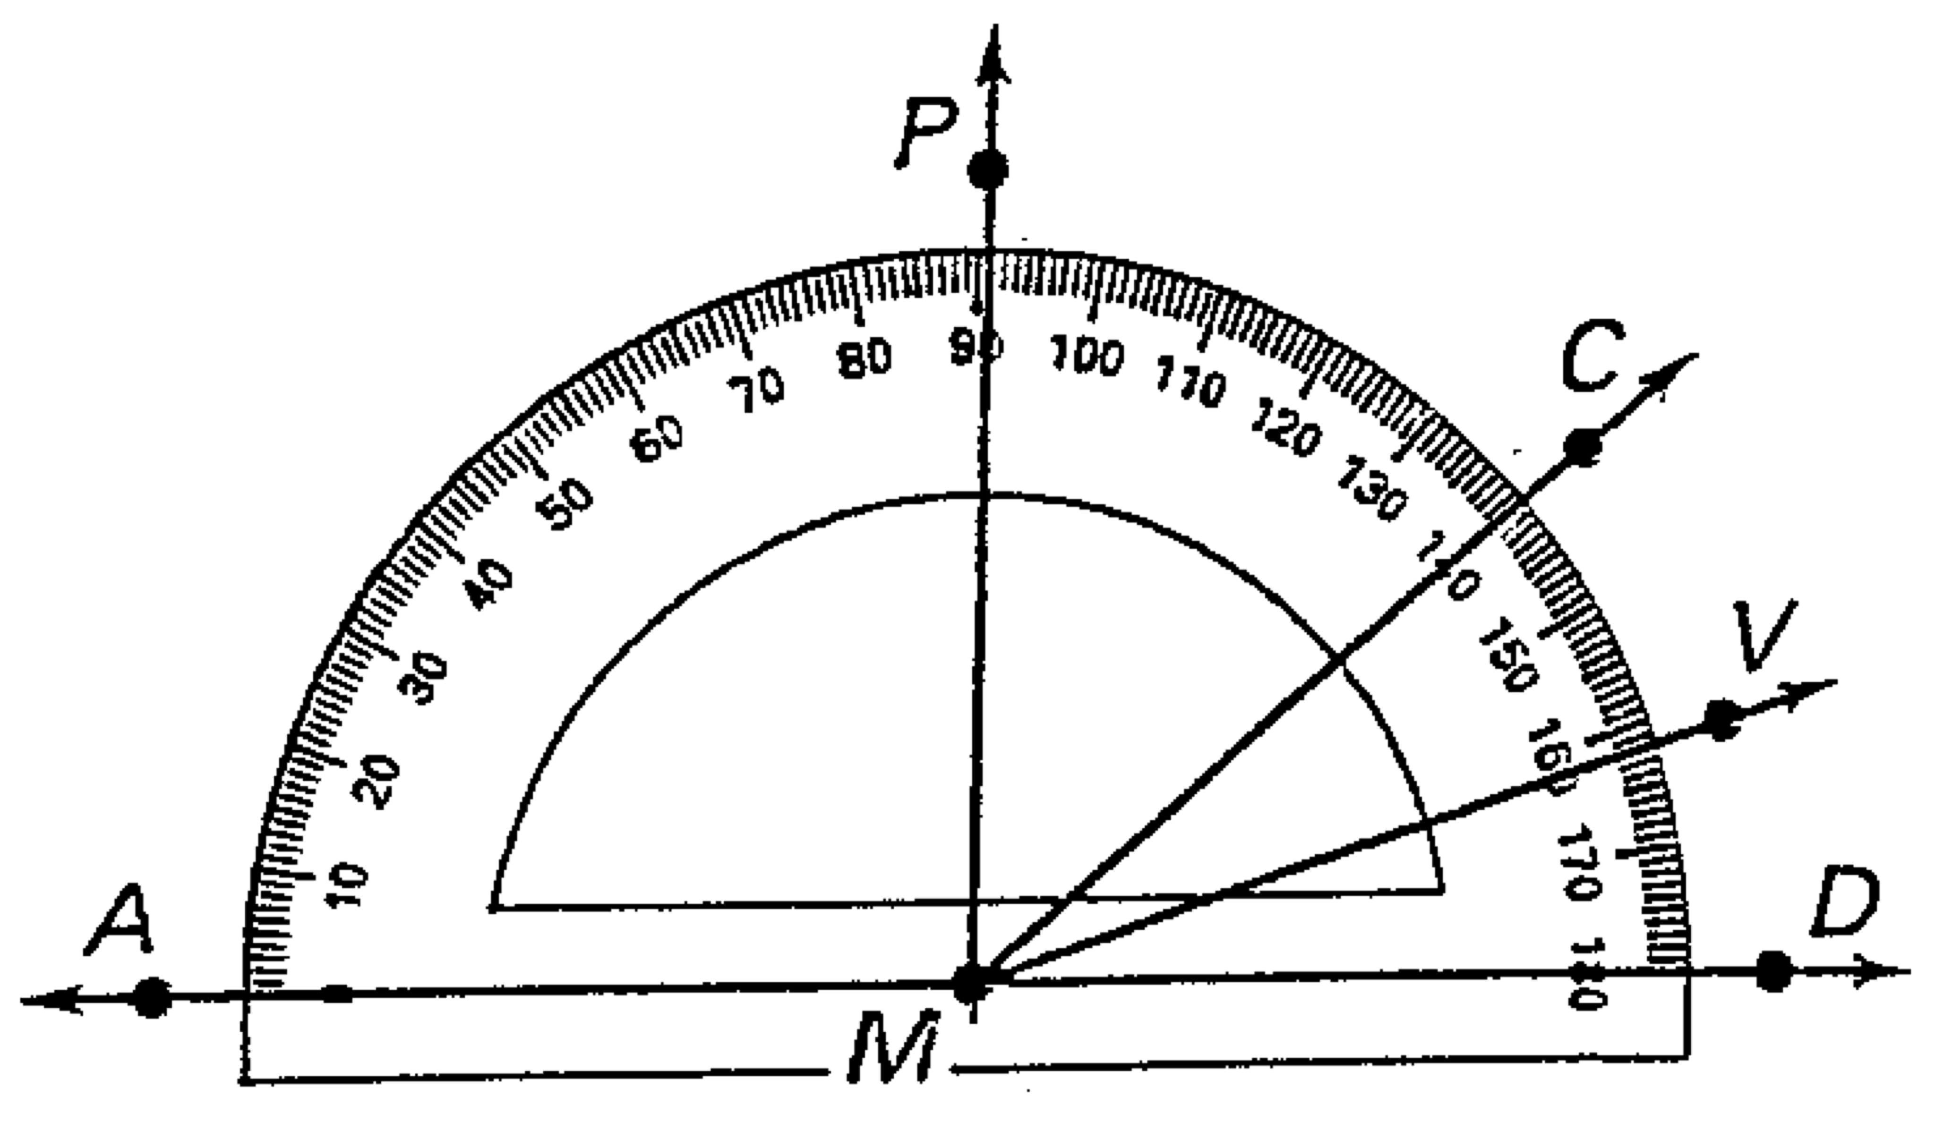

9. State what type of angle is formed

a. 

b. 

**Complete the following.**

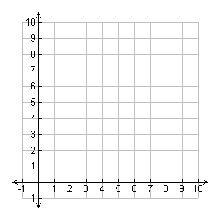

10. Plot the following relation on the coordinate plane

{(2,2), (5,1), (7,3), (9,1), (3, 9)}

Fill in the next two values of the table and then describe the behavior

11.

|  |  |  |  |  |  |  |  |
| --- | --- | --- | --- | --- | --- | --- | --- |
| X | 1 | 2 | 3 | 4 | 5 | 6 | 7 |
| Y | 17 | 29 | 41 | 53 |  |  |  |

Behavior:

12.

|  |  |  |  |  |  |  |  |
| --- | --- | --- | --- | --- | --- | --- | --- |
| Term | 1 | 2 | 3 | 4 | 5 | 6 | **Behavior** |
| Value | 4 | 16 | 64 | 256 |  |  |  |

13. The Domain of a function represent the ________ values, while the Range represent the ____________ values.



14. State the Domain and Range. Is this a function? Yes/No

15. Write the following table in function notation, f(x)=a

|  |  |  |  |  |
| --- | --- | --- | --- | --- |
| x | -2 | -1 | 0 | 3 |
| f(x) | 4 | 4 | 2 | 3 |

16. If f(x) = 5x + 2 find f(4).

17. Simplify.

* 1. 3x – 4+7x – 1 b. 4x2 – 6x +3 + x(x – 5)

18. Find (f + g)(x) if f(x) = 5x – 2 and g(x) = 8x + 5

19. Find (f - g)(x) if f(x)5x – 2 and g(x) = 8x + 5 (don’t forget to distribute the negative)

20. Find (f g)(x) **AND** (f/g)(x) for f(x) = 3x2 + 2x – 6, g(x) = x2 + 2

**Solve. (note: can either be one solution, all solutions, or no solutions.)**

21. a. 6x = 48 b. 3x – 4 = 20

22 a. b. 2(n + 4) = 2n – 9

23. a. 6(2c +1) = 12c +6 b. 3(x – 2) +2 = 6x + 8

24. The inverse of Multiplication is ___________________. The inverse of subtraction is _________________________.

25. According to the following expression, circle the COEFFICENT(s). 3x3  - 4x +2

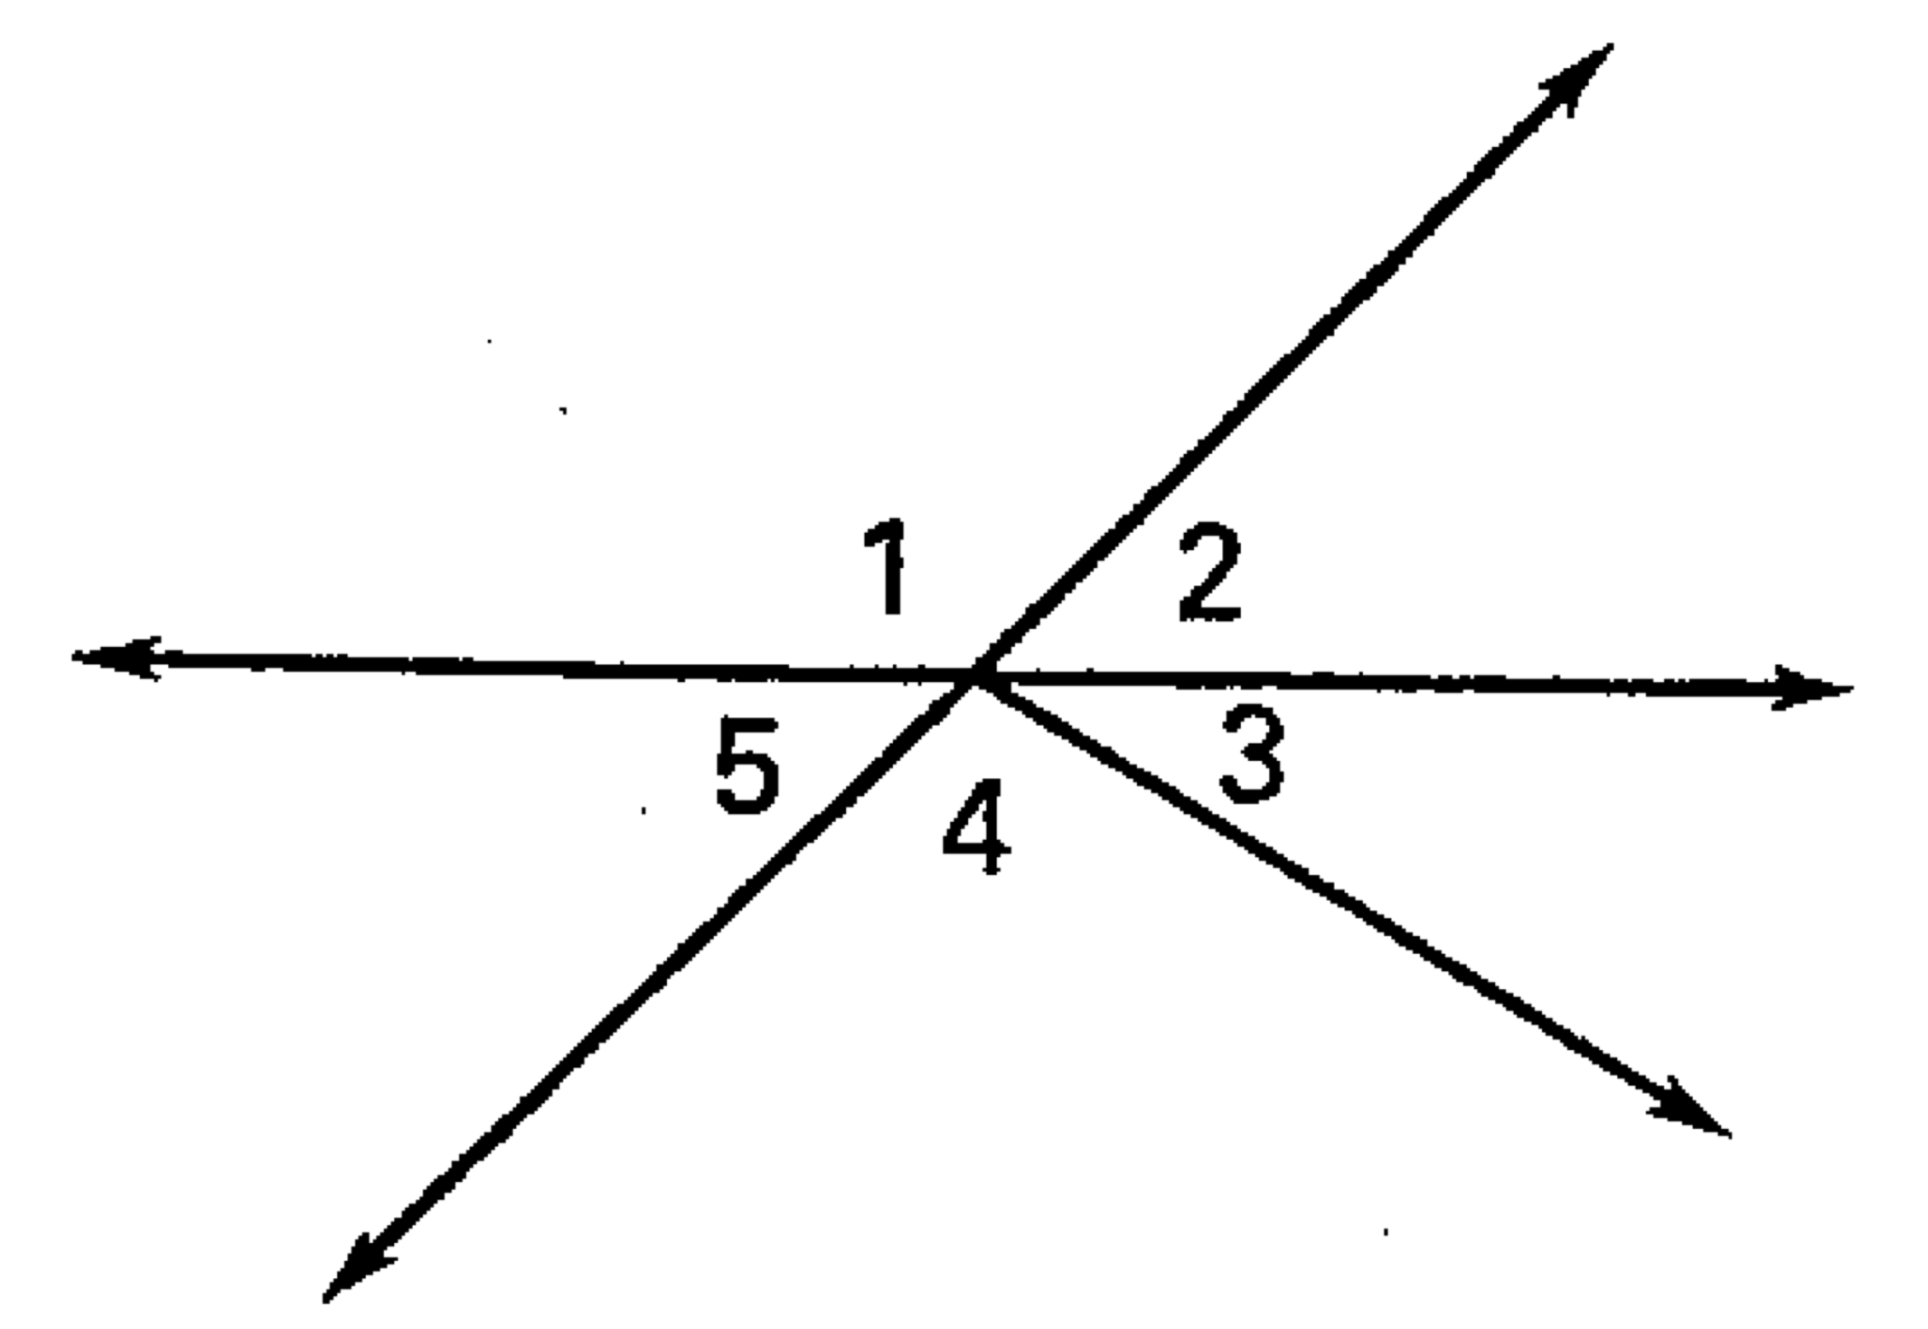26. Answer the following.

1. If *m* 2 = 43°, then *m* 5 = _______.
2. If *m* 1 = 104°, then *m* 5 = _______.
3. Are 1 and 2 a vertical angles?
4. Are 2 and 5 vertical angles?
5. Are 1 and 5 supplementary angles?
6. Are 3 and 4 complementary angles?

 (27-29) Classify the triangle by its angles and by its sides.

 27. 28. 29.



(30 – 31) Find the measure of the numbered angles.

 30. 31.

 (32 -33) Find the measure of the numbered angle.

32. 33.

(34 – 36) 

34. Sketch the triangles 35  36. 

37. If ** then 

(38 – 39). Decide whether enough information is given to prove that the triangles are congruent. If there is enough information, state the congruence postulate you would use.

38.  39  



(40-43) State the third congruence that must be given to prove that  using the indicated postulate or theorem.

40. ASA Congruence Theorem 41. AAS Congruence Theorem



42. SSS Congruence Theorem 43. SAS Congruence Theorem





(44 –45) Solve for *x* and *y*.



 44. 45.

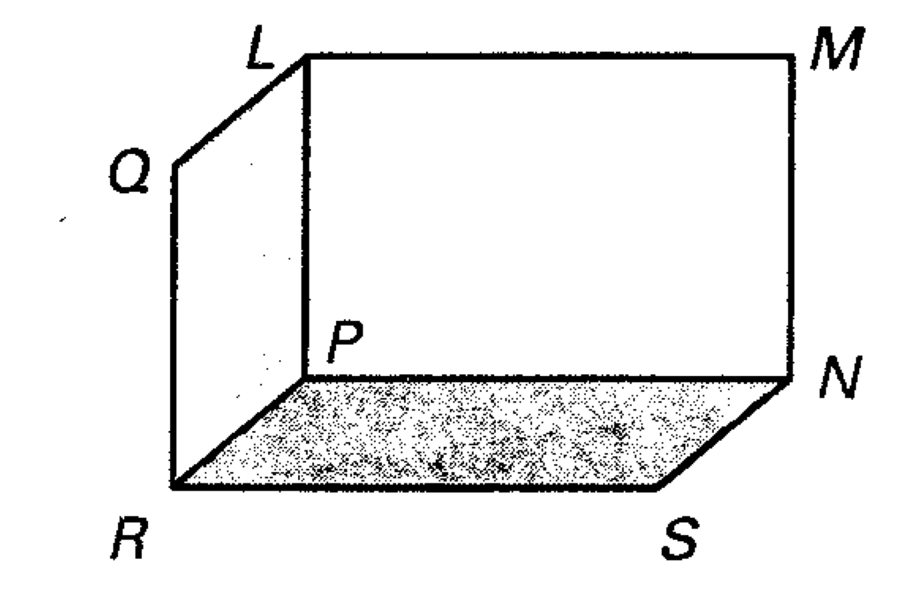State whether the following lines are parallel,

perpendicular, or skew

46.  and 

47.  and 

48.  and 

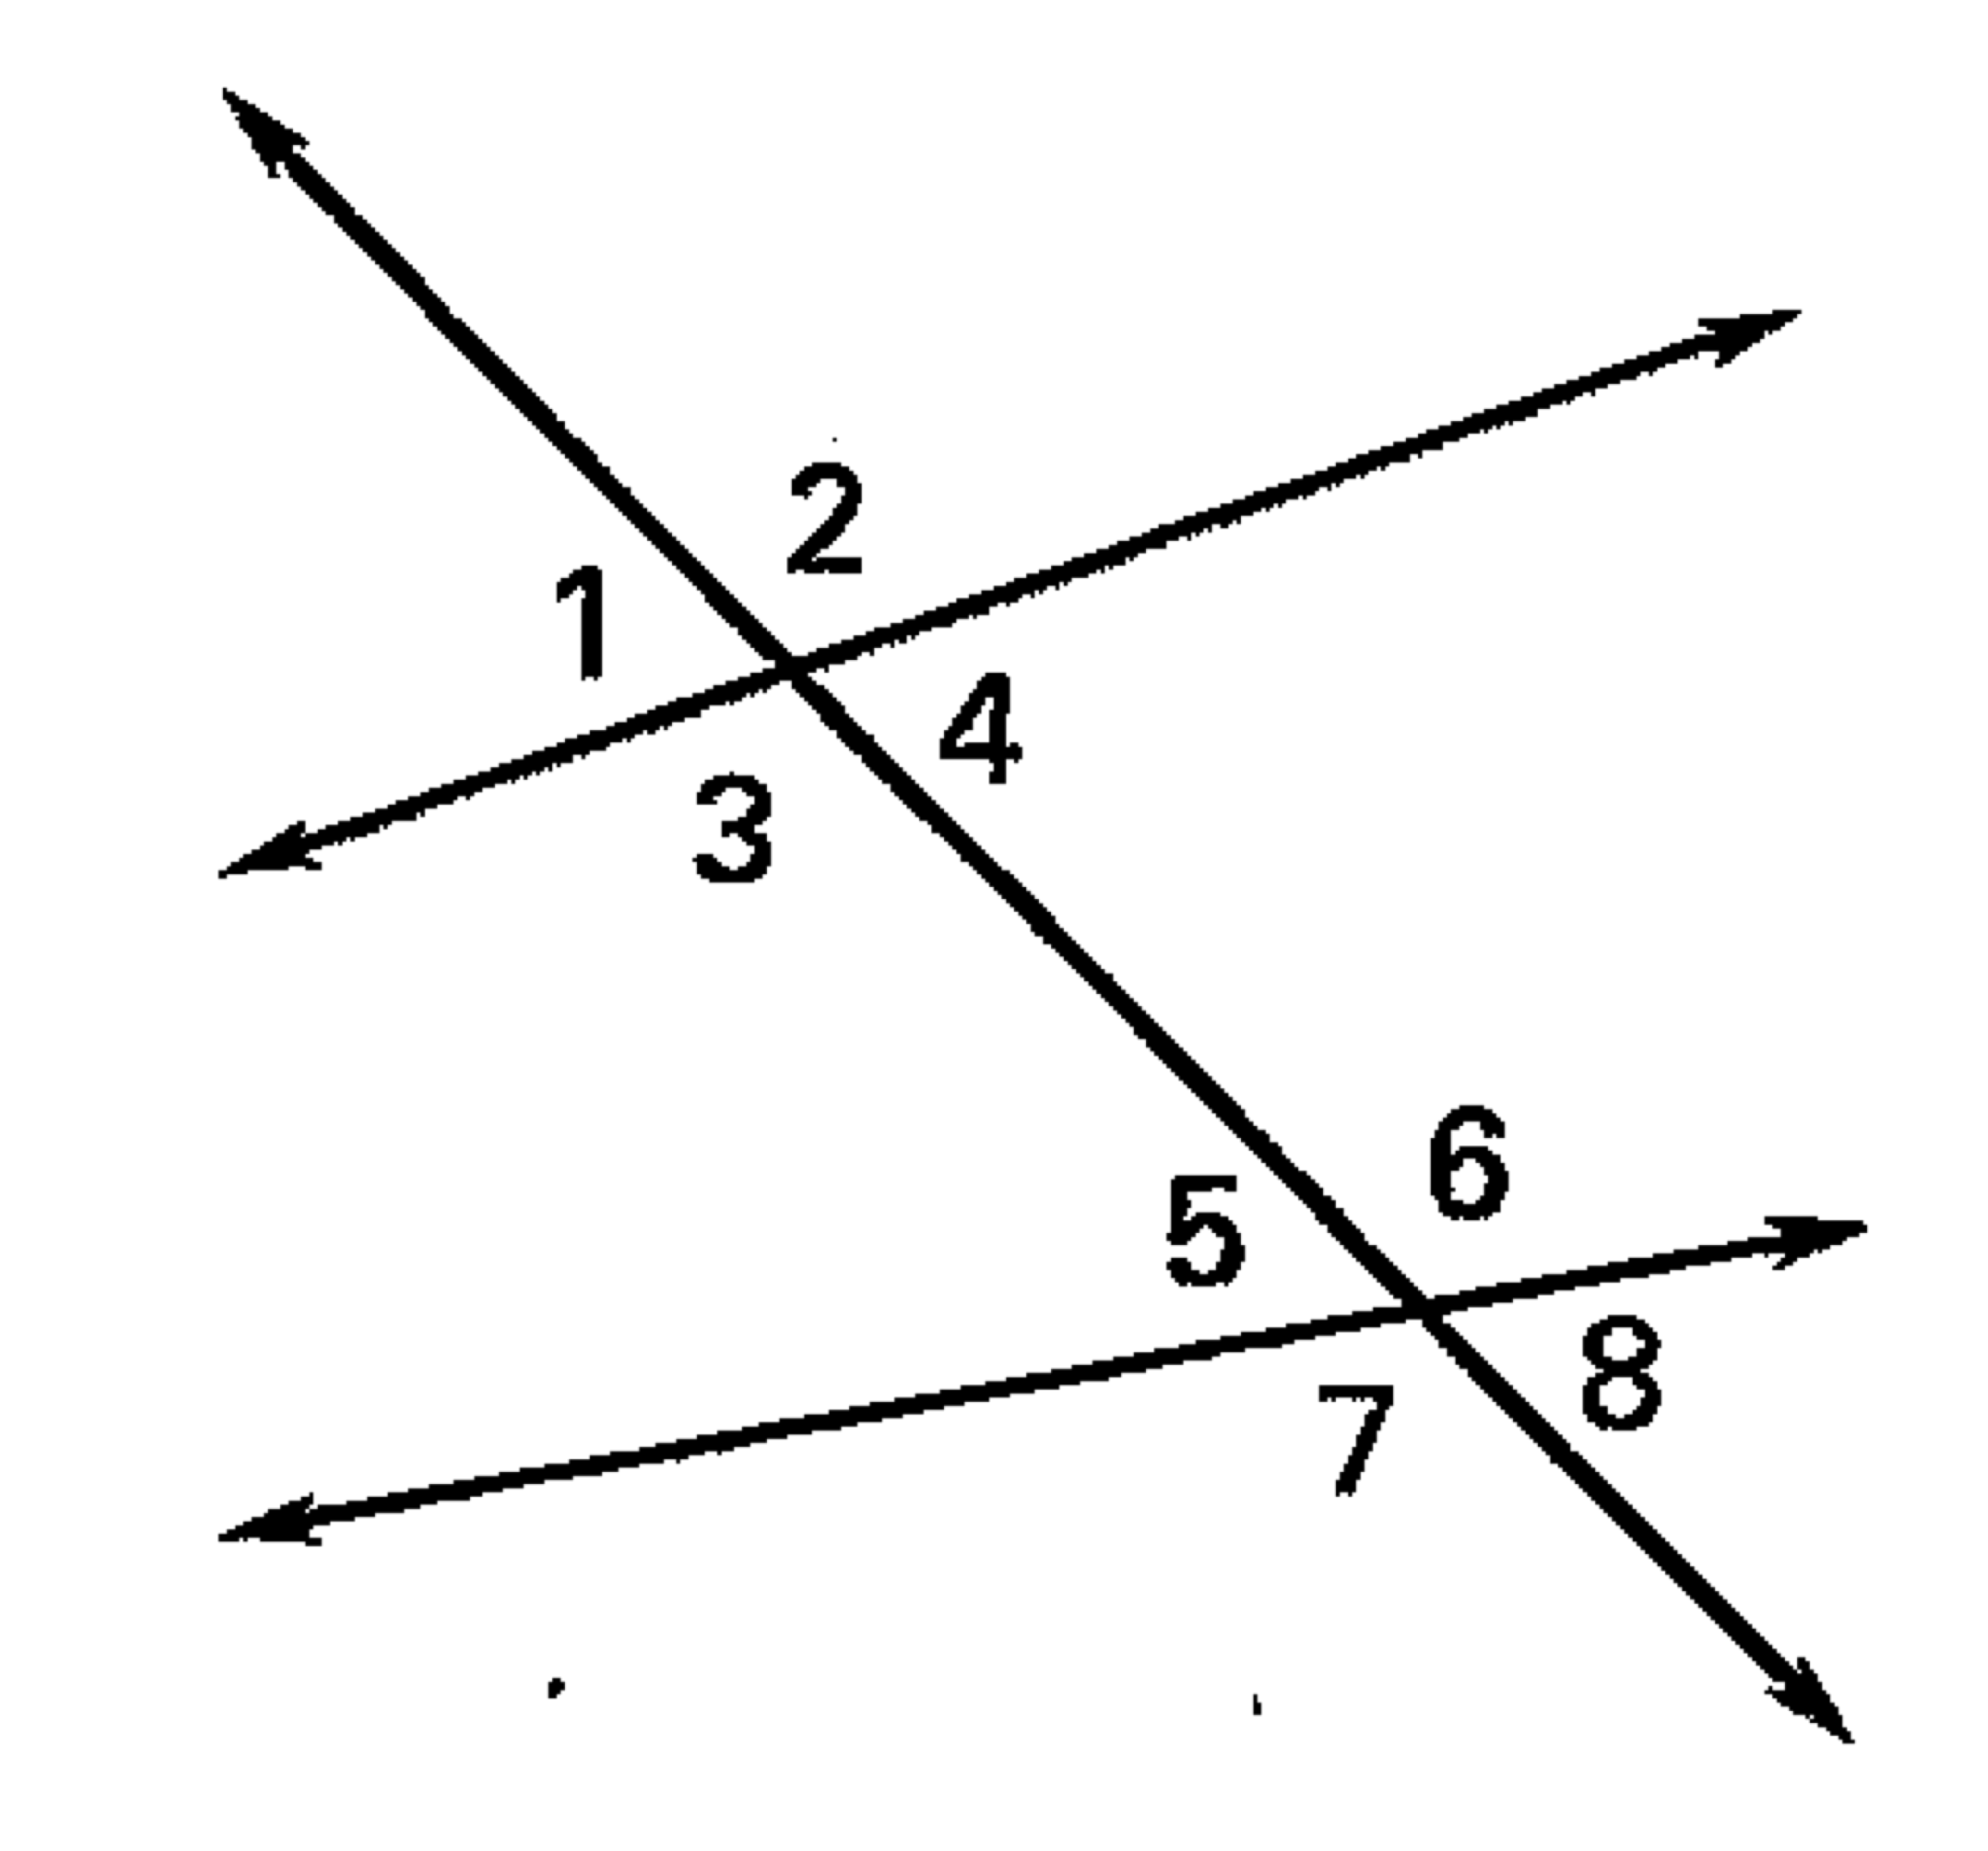State the relationship between the following angles

49.  50. 

51.  52. 

53.  54. 

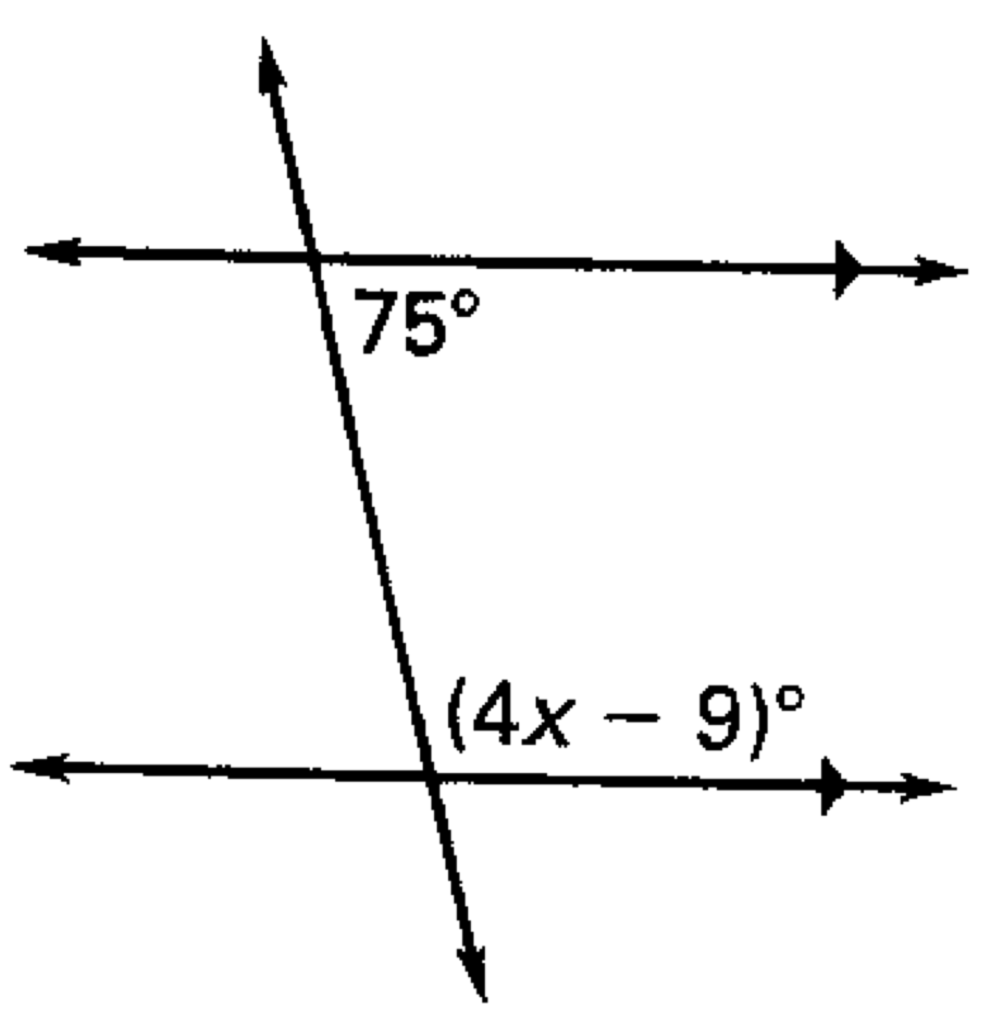Solve for the value of x

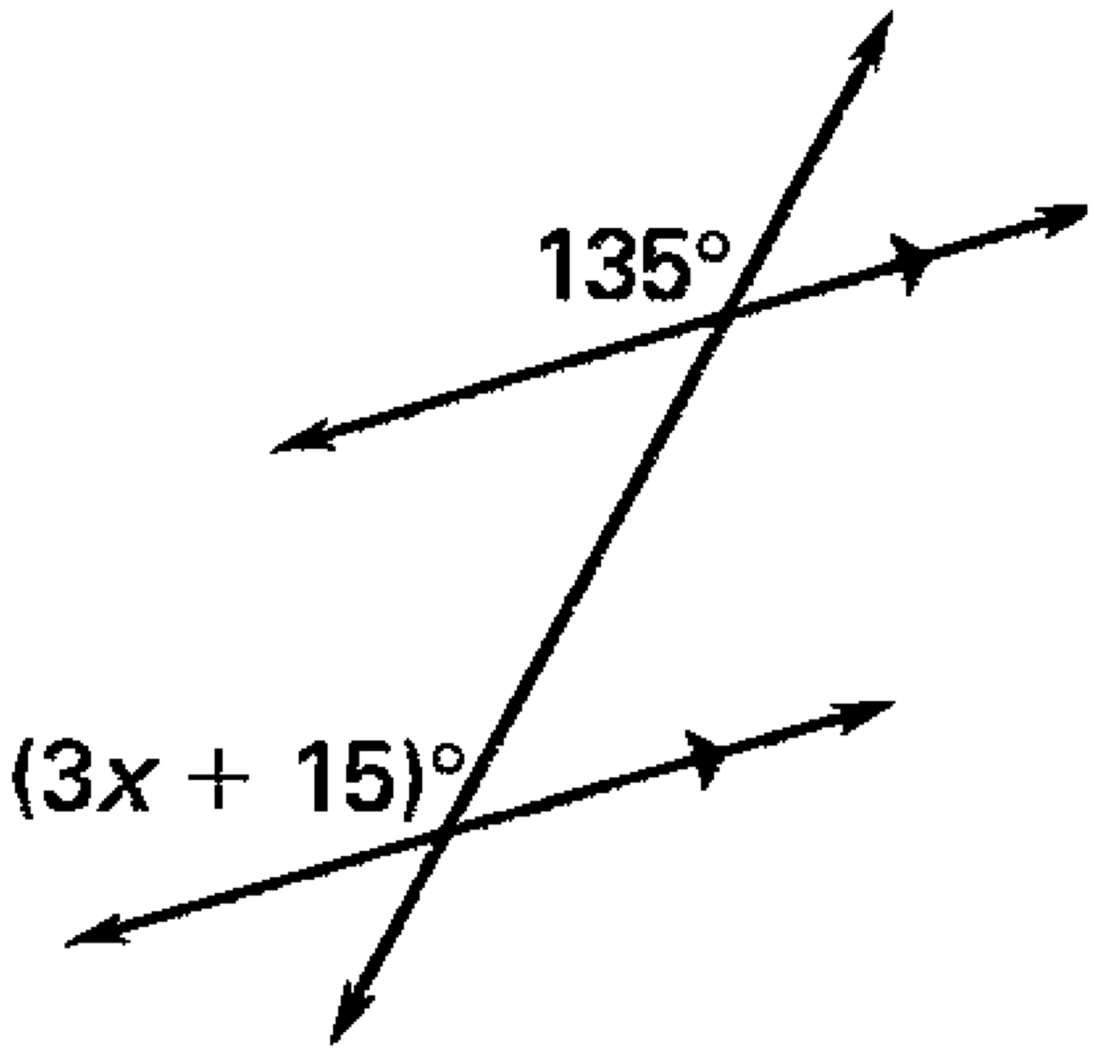55. 56.

Find the slope from the following tables and also ordered pairs

57. a. A(0, −6) b. C(−4, 10)

B(2, 4) D(−8, −7)

58. a. b.

|  |  |
| --- | --- |
| x | y |
| -4  -2  0  2  4 | 5  2  -1  -4  -7 |

|  |  |
| --- | --- |
| x | y |
| -5  -4  -3  -2  -1 | 1  3  5  7  9 |

59. Determine if the lines are perpendicular parallel or neither and explain why.

a)  b)  c) 

  

60. What is the parallel and perpendicular slope of the following line?

61. Fill in the following:

The slope intercept form of a line is: _______________________________

m stands for: ___________ and b stands for: _______________

The point-slope form of a line is:__________________________________

The equation for a vertical line is:__________________________________

The equation for a horizontal line is:________________________________

The slope of a horizontal line is: _______________

The slope of a vertical line is: _________________

*Write an equation of the line in* ***slope-intercept form*** *–* ***REMEMBER – you need the slope and y-intercept.***

62) m = -1, b = 6 63) m = , b = 

64) through (-3, 2), m = 4 65) through (2, 5), slope = undefined

66) (2, 4), (5, 7) 67) (-3, -6) (1, -6)

*Write an equation in* ***slope intercept form*** *with the given requirements.*

68) through (4, 8), parallel to  69. Through (2, 3), perpendicular to y = 3x -2

*Write an equation of the line shown in the graph*

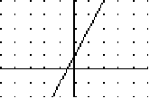70) 71) 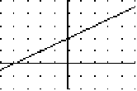

Slope:______________________ Slope:______________________

y-intercept:__________________ y-intercept:__________________

Equation: ___________________ Equation: ___________________

*Write an equation in* ***point-slope form*** *of the line-* ***REMEMBER: you need the slope and a coordinate point***

72) (5, -2), m =  73) (3, -2) (4, 6)

Find the x and y intercepts of the following equations:

74. 75.

Use the substitution method to solve the following systems of equations:

76. 2x – y = -1

2x + y = -7

77. -x + y = 1

2x + y = 4

Use the elimination method to solve the following systems of equations

78. 3x + y = 3 79. 7x + 2y = 1

3x – y = 0 5y = 15

Determine the number of solutions illustrated by these graphs.

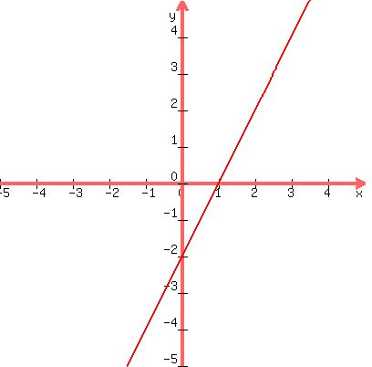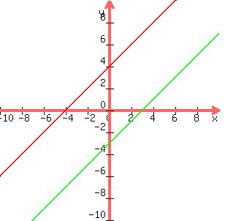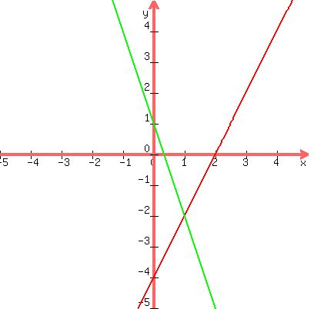

80. Solution 81. Solution 82. Solutions

83. Write the symbol for the following expressions:

less than or equal to _______ greater than _______

at most _______ at least _______

no more than _______ no less than _______

more than _______ great than or equal to _______

84. Solve and Graph 

| | | | | | | | | | | | | | |

-6 -4 -2 0 2 4 6

85. Solve and Graph 

| | | | | | | | | | | | | | |

-6 -4 -2 0 2 4 6

86. Solve and graph 

| | | | | | | | | | | | | | |

-6 -4 -2 0 2 4 6

87. Identify the transformations in the following:

a) b)  c)  d) 

Label the following exponential equations as either growth or decay.

88)  89)  90)  91) 

Evaluate the following:

92) for x=0 and x= 2 93) Find f(3) for 

94. Find the mean, median, mode and standard deviation of: 3, 5, 6, 6, 7, 8, 9, 10, 12, 14

95. Find the mean, median, mode and standard deviation of: 2, 3, 5, 5, 5, 6, 7, 8, 9, 10, 10, 11, 12, 13, 14, 15

96. Find the 5 number summary of: 3, 5, 6, 6, 7, 8, 9, 10, 12, 14

97. Find the 5 number summary of: 2, 3, 5, 5, 5, 6, 7, 8, 9, 10, 10, 11, 12, 13, 14, 15

98. Draw an example of a translation 99. Draw an example of a Rotation

100. Draw an example of a dilation