**5.1 Writing Linear Equations in Slope-Intercept Form**

Name:________________________________________ Date:____________ Period:_____________

In Unit 4 we introduced slope-intercept form (y=mx+b). Where ____ is the slope and ____ is the y-intercept.

**Ex. 1** Writing an equation of a line

1. m = -2 b = 5 2. m = 6 b = -3 3. m = ½ b = 5/3

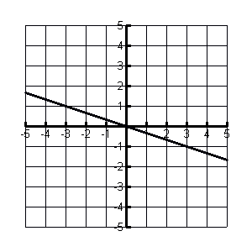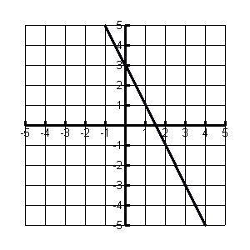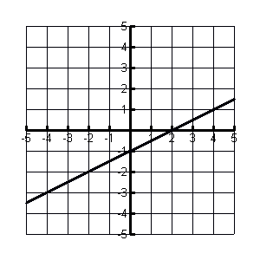**Ex. 2** Use the graph to write an equation

1. a 2. 3.

m = ____ m = ­­­­____ m = ____

b = ____ b = ____ b = ____

equation: ________________ equation:_________________ equation:__________________

4. 5.

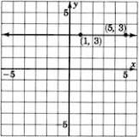 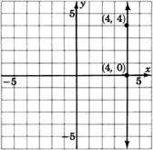

m = ­­_____ m = _____

b = _____ b = ____

equation:_________________________ equation:_________________________

**5.2/5.5 – Writing Linear Equations Given the Slope and a Point**

**Goal 1: Using Slope-Intercept Form**

**Ex. 1**

1. through: (2, −1), m = 3 2. through: (1, 4), m = −2 3. through: (-2, 3), m = −1/2

y = mx + b (write equation)

y = 3x + b (plug in slope)

(-1) = 3(2) + b (plug in x and y)

-1 = 6 + b (simplify)

-7 = b (solve for b)

y = 3x – 7 (plug in b)

4. through: (2/16, 4), m = 0 5. through (3,-4), m = undefined 6. through: (-3/4, 2/16), m = 1/2

**Goal 2: Using point-slope form**

The point-slope form of an equation is: _________________________________ where m is _______

**Ex. 2***Write an equation in point-slope form of the line that passes through the given point and has the given slope.*

1. (-3, 1), m = 3 2. (6, 2), m = ½ 3. (1/2, 4), m = 9

**Ex. 3** *Write an equation in point-slope form of the line that passes through the given points*

1. (2, 3), (5,4) 2. (3, -2), (-1, 4) 3. (1/2, 2/3), (3/4, 4/9)

(Hint: Solve for m first)

**5.3/5.6 – Writing Linear equations given two points, and standard form**

**Ex. 1** *Write an equation of the line that passes through the points in* ***slope-intercept*** *form*

1) (-2, 5), (3, 8) 2) (1, 2), (-1,-2)

Find m

Find y-intercept

Write the equation

3) (-1, 3), (-2, 4) 4) (-8, -3), (10, -3)

**Standard Form: __________________________________________**

Steps for writing in standard form: 1st put all the x’s and y’s on one side of the equation

2nd put all the other numbers on the other side of the equation

3rd simplify (get rid of fractions)

**Ex. 2** – rewrite the equation in standard form

*Write the equation in standard form*

5) y = 3x + 2 6) 2y + x = -(1/2) x + 3/2