9-5 Transformations Day 2 Name: _______________________________________

Homework Date: __________________ Class: _______________

State the transformation and then graph using the transformation

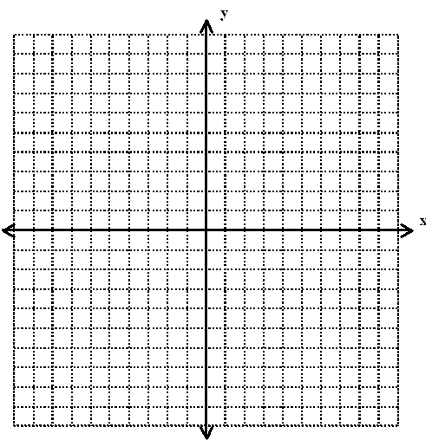1.  2. 

3.  4. 

5.  6. 

Determine whether the set of data shown below displays exponential behavior. Explain why or why not.

7.

|  |  |  |  |  |  |
| --- | --- | --- | --- | --- | --- |
| X | -4 | 0 | 4 | 8 | 12 |
| y | 2 | -4 | 8 | -16 | 32 |

8.

|  |  |  |  |  |
| --- | --- | --- | --- | --- |
| X | -8 | -6 | -4 | -2 |
| y | 0.25 | 0.5 | 1 | 2 |

Describe the transformation from the parent function for each of the following

9.  10. 