**9-3 Exponential Functions** Name: ________________________________

**Homework** Date: _______________ Class: __________

Evaluate the following functions

1.  for x=0 and x= 2 2. Find f(3) for 

State the domain and range of the following graphs

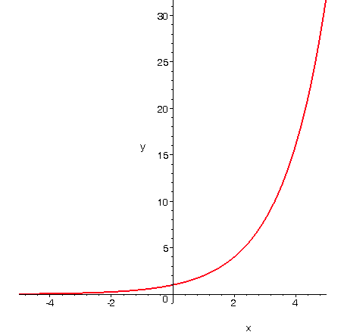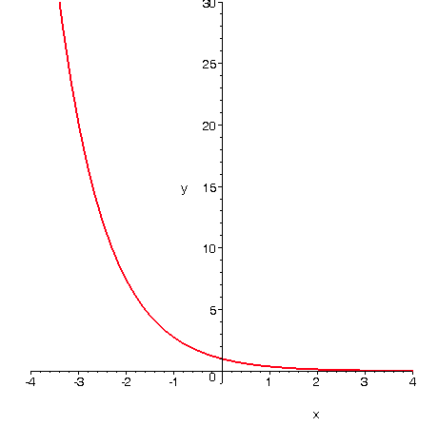3. 4.

Domain: Domain:

Range: Range:

Graph the following using a table of values. Then state the y-intercept, domain, and range.

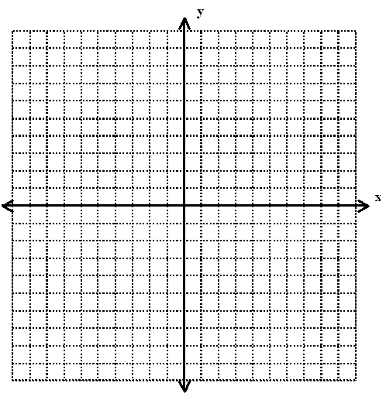5. 

|  |  |  |  |
| --- | --- | --- | --- |
| x |  | y | (x,y) |
| -2 |  |  |  |
| -1 |  |  |  |
| 0 |  |  |  |
| 1 |  |  |  |
| 2 |  |  |  |

y-intercept _______________ Domain: ________________ Range:_______________

6. 

|  |  |  |  |
| --- | --- | --- | --- |
| x |  | y | (x,y) |
| -2 |  |  |  |
| -1 |  |  |  |
| 0 |  |  |  |
| 1 |  |  |  |
| 2 |  |  |  |

y-intercept _______________ Domain: ________________ Range:_______________

7. 

|  |  |  |  |
| --- | --- | --- | --- |
| x |  | y | (x,y) |
| -2 |  |  |  |
| -1 |  |  |  |
| 0 |  |  |  |
| 1 |  |  |  |
| 2 |  |  |  |

y-intercept _______________ Domain: ________________ Range:_______________

State whether the following equations are growth or decay

8.  9.  10. 