Secondary Math I Name:_________________________________
8-3 Domain, Range & Reasonable Homework Date:_________________ Class:__________

For 1 – 5 list the domain and range of each function:
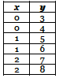
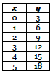
1. 2. 3.

Domain:

Range:

Domain: Domain:

Range: Range:

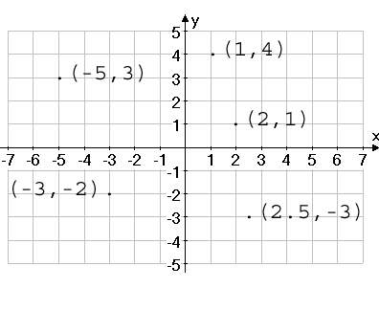
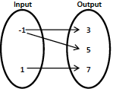
4. 5.

Domain: Domain:

Range: Range:

6. Draw a graph that represents the following situation:

Arianna is speeding along the highway when she sees a police officer; she slows down so she will not get pulled over then speeds up again once he is out of sight. Graph time on the horizontal axis and her speed on the vertical axis..

