Name: ___________________________ Date: ___________ Period: ________

# Secondary Math II 8-2 Homework

# Transformations

Match a graph to the function. Explain your choice.

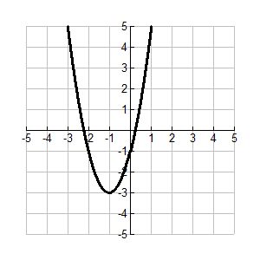______1.  ______2.  _______3. 

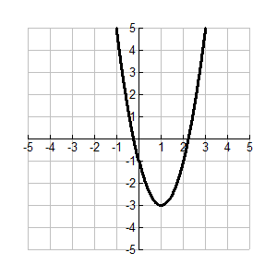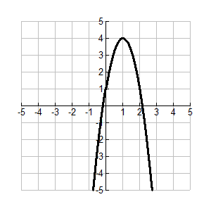a. b. c.

Write each quadratic function in vertex form. Describe the transformations. Give the coordinates of the vertex and the equation for the axis of symmetry.

4.  5.  6. 

Describe how to transform the graph of  into the graph of the given function. Sketch each graph by hand.

7.  8.  9. 

