Secondary Math I Name:_________________________________
8-1 Def. of a Function Homework Date:_________________ Class:__________

Tell whether each of the following relations represent a function. Why or why not?

X | Y
1 | -1
0 | 9
3 | 7
1 | 4
X | Y
0 | -3
1 | 7
2 | 9
3 | 11
1/2.
3. {(1,3), (2, 7), (0, 8), (1, 7)}
3.

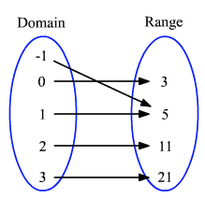
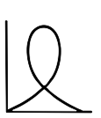
4. 5.

6. Write the following ordered pairs in function notation and a mapping
{ (3,5), (-2,1), (0,5), (5,0) }

7. Write the following as a table and graph them
f(-4)= -2, f(-2)=0, f(2)=2, f(5)= 4

8. Provide an example of a relation that is a function

9. Provide an example of a relation that is not a function

