7-2 – **Fitting a Line to Data and Predicting**

Last class period we learned about correlation and scatterplots. Example: Label each graph with its correlation. (positive, negative, no corr.)

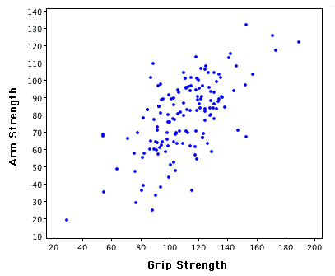 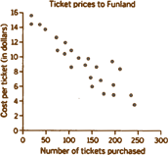 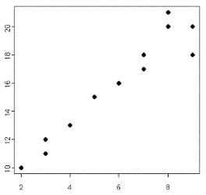

_________________________ ________________________ _________________________

When we notice that there is either a _______________ correlation or a ____________________ correlation we can draw a ______________ line or _____________of _________ ________. This line allows us to make more accurate ______________________ about the behavior of data. We can decide when a ______________ model can be used to represent real-life ___________.

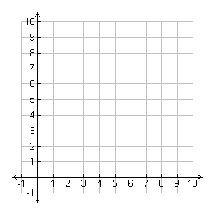We do this by _________________ a scatter plot of the data.

Example:

|  |  |
| --- | --- |
| X | Y |
| 1 | 4 |
| 3 | 6 |
| 4 | 7 |
| 7 | 10 |
| 9 | 12 |
| 10 | 13 |

On the graph, are the points almost in a straight line?

If the points look like they’re almost in a straight line on the graph, then the data can be modeled with a ____________________________.

We can do this by drawing a line on a graph. Everyone’s ____________ lines will not be exactly the __________. You make your ___________ estimate on a __________ that reflects your data. The most important key is your line must ________________ pass through **at least** ____________ points.

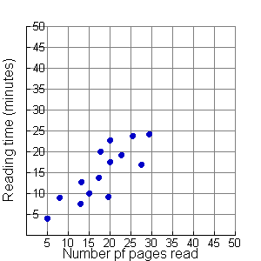**Example 1**: Kearstyn recorded the time she has spent reading and the number of pages she has read. The data is displayed in the scatterplot below.

1. Draw a trend line

2. Find the slope between the 2 points.

3. Use point-slope form to find the equation of the line.

When the points on a scatter plot can be approximated by a line with ____________________ slope, x and y have a _____________________ correlation. When the points can be approximated by a line with ___________________ slope, x and y have a ______________________ correlation. When points CANNOT be approximated by a straight line, there is __________________________________.

**Predicting Values based on your Best Fit Lines**

Once you have created an __________________ that models your data, you can use the equation to make _____________________ on further occurrences of the event you are modeling. To make a _____________________ you will substitute into your equation. Make sure if you are substituting the ________________ value you substitute for the ________ and if you are substituting the ________________ value you substitute for the ________.

4. From your trend line above predict the amount of time it would take Kearstyn to read 50 pages.

**Example 2**: A pool recorded the maximum temperature during a summer day and the number of people who came to the pool. The data is below:

|  |  |  |  |  |  |  |  |  |  |  |  |
| --- | --- | --- | --- | --- | --- | --- | --- | --- | --- | --- | --- |
|  |  |  |  |  |  |  |  |  |  |  |  |
|  |  |  |  |  |  |  |  |  |  |  |  |
|  |  |  |  |  |  |  |  |  |  |  |  |
|  |  |  |  |  |  |  |  |  |  |  |  |
|  |  |  |  |  |  |  |  |  |  |  |  |
|  |  |  |  |  |  |  |  |  |  |  |  |
|  |  |  |  |  |  |  |  |  |  |  |  |
|  |  |  |  |  |  |  |  |  |  |  |  |
|  |  |  |  |  |  |  |  |  |  |  |  |
|  |  |  |  |  |  |  |  |  |  |  |  |

200

100

70 80 90 100 110

Maximum Daily Temperature (°F)

Number

of

People

1. Draw a trend line

2. Find the slope between the 2 points.

3. Use point-slope form to find the equation of the line.

4. Predict pool use if the temperature reaches 105°.

5. If there are 375 people at the pool, approximately how hot is it outside?