Name:___________________________________ Period:_______ Date:________________

# 7-1 Scatterplots Homework

For #1 - 2: A) What type of correlation ? (positive, negative, or no correlation)

|  |  |
| --- | --- |
| Years of education | Annual income (in $ 1,000 ‘s) |
| 6 | 16 |
| 8 | 17 |
| 10 | 21 |
| 14 | 35 |
| 16 | 42 |
| 20 | 51 |

B) What is the strength of the correlation? (is it strong, moderate or weak correlation)

1. 2.

•

•

•

•

•

•

•

•

•

•

•

•

•

•

•

•

•

______________ _______________

For #3 - 5: What type of correlation should exist between the variables ?

_____________ 3. the amount of pollution in a river, the number of fish living in that river

_____________ 4. the amount of rainfall, the percent chance of winning the lottery

_____________ 5. time spent working, amount of money earned

*For #6 – 8, underline the independent variable and circle the dependent variable.*

dep.

indep.

a person’s blood pressure , a person’s age

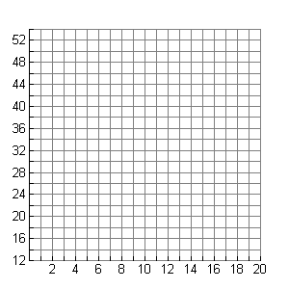6. time it takes to open your locker , how many numbers in your combination

7. incline of a ramp , speed of skateboard

8. cost of groceries , number of people in your household

### 9. Graph the data and a trend line.

Remember to label the axes.

10. What is the independent variable ? Predict the income of a person with 12 years

of education.

### 