**6-5 Graphing Linear Inequalities** Name:_________________________________

Homework Date:___________________ Class:________

Determine if the line is dotted/ solid

1.  2. 

Determine if we shade above or below the line

3.  4. 

Graph the following Linear Inequalities

5.  6.  7. 

Line: Line: Line:

Shading: Shading: Shading:

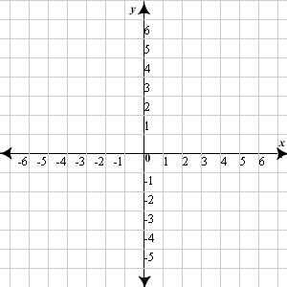

8.  9.  10. 

Line: Line: Line:

Shading: Shading: Shading:

