Secondary Math 2 Name_________________________________________

6-2 Intro to Cubics and Quadratics Homework Period_________

**Identify the Vertex**

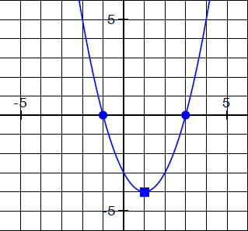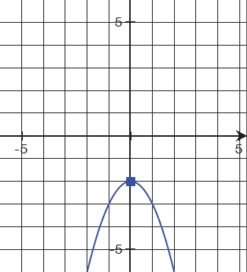1. 2. 3. 

Vertex: ___________________

 

Vertex: ___________________ Vertex: __________________

**Identify the Inflection Point**

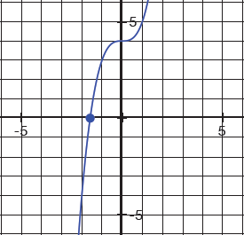4. 5.  6. 

Inflection Point: _______________ Inflection Point: _______________

Inflection Point: _______________

**Graph the function**

7.  8.  9. 

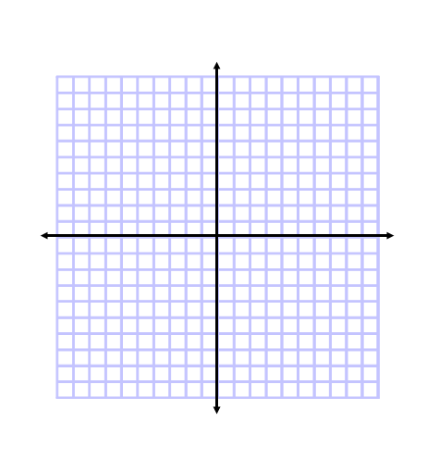

**10. Label as Even, Odd, or Neither**

