Secondary Math 2 Name_________________________________________
5-4 Contextual Trig Period_________
HOMEWORK

Draw a picture and use trigonometric ratios to solve.
1. A sheet of paper is 11 inches long and 8 ½ inches wide. Find the measures of the acute angles of the right triangle formed by cutting the sheet of paper from one corner to the opposite corner. Round to the nearest degree.

Smokey the Bear

2. Smokey the Bear is atop a 100-foot tower, looking out over a fairly level area for careless people who might start fires. Suddenly, he sees a fire starting. He marks down the direction of the fire, but doesn’t know how far away the fire is. To figure out this distance, Smokey grabs his handy protractor. Since he is high up on top of the tower, he has to look slightly downward toward the fire. He finds that his line of sight to the fire is at an angle of 6 below horizontal, as shown in the diagram below.
(Note: the diagram is not drawn to scale)
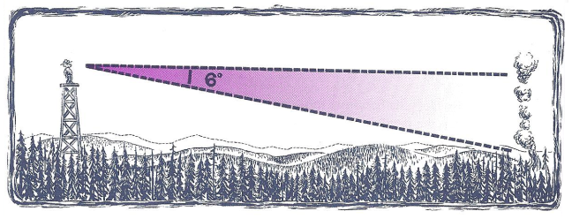

- How far is Smokey (up on the tower) from the fire on the ground?

b.) How far is the base of Smokey’s tower from the fire?

4) You are hiking up a mountain peak. You begin hiking at a trailhead. The trail ends near the summit at 14,255 ft. The horizontal distance between these two points is about 17,625 feet. Estimate the angle of elevation from the trailhead to the summit. Round your answer to the nearest tenth.
Horizontal distance 17,625 ft
14,255 ft
summit
trailhead

5) A builder needs to construct a wheelchair ramp 35 feet long that rises to a height of 6 feet above ground level. Find the angle (in degrees) that the ramp should make with the ground.

6) A six-meter-long ladder leans against a building. If the ladder makes an angle of 60° with the ground, how far up the wall does the ladder reach?

How far from the wall is the base of the ladder? Round your answers to two decimal places, as needed.

8) A boy flying a kite lets out 300 feet of string which makes an angle of 38° with the ground. Assuming that the string is straight, how high above the ground is the kite?

9) A straight road to the top of a hill is 2500 feet long and makes an angle of 12° with the horizontal.
Find the height of the hill.

