Secondary Math II Name:_________________________________

5-3 Right Triangles Period:__________

HOMEWORK

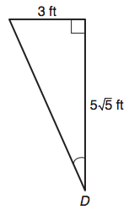**Find the missing side length:**

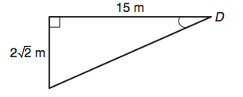1. 2.

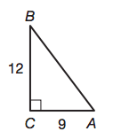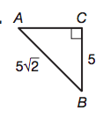

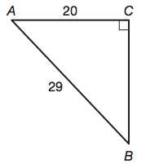3. 4. 5.

**Draw a triangle and find all other trigonometric functions for problems 14-16:**

14.  16. 

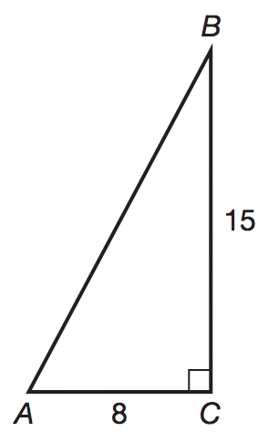**Find all trigonometric functions for problems 8-10:**



45

8. 9. 10.

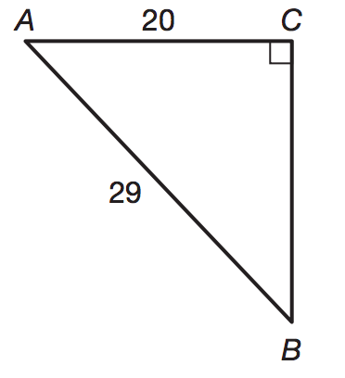

14

11

53

8