**5-1** Linear Patterns Homework Name: ________________________________

1. Create a table and graph to represent how the perimeter is growing

|  |  |
| --- | --- |
| step | toothpicks |
|  |  |
|  |  |
|  |  |
|  |  |

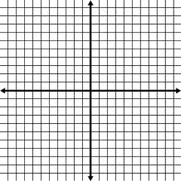

1. From the information above, state the rate of change, initial value, and write a rule
2. Find the slope, y-intercept, and write a rule for the following

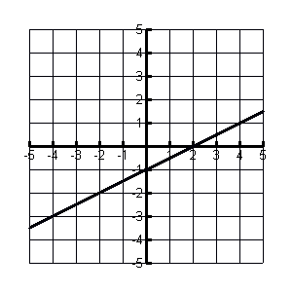

|  |  |
| --- | --- |
| x | y |
| -3 | 0 |
| 0 | 4 |
| 3 | 8 |
| 6 | 12 |

Slope:__________ Slope:_____________

y-intercept:___________ y-intercept: __________

Rule: Rule:

1. 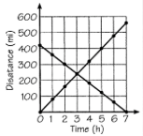Find the rate of change the represents the following lines

For numbers 5-6 fill in the remaining pieces of the table and then write a rule for the linear pattern:

5.

|  |  |  |  |  |  |  |  |
| --- | --- | --- | --- | --- | --- | --- | --- |
| X | 0 | 1 | 2 | 3 | 4 | 5 | 6 |
| Y | 25 | 20 | 15 | 10 |  |  |  |

Rule:

________________________________

6.

|  |  |  |  |  |  |  |  |
| --- | --- | --- | --- | --- | --- | --- | --- |
| X | 1 | 2 | 3 | 4 | 5 | 6 | 7 |
| Y | 48 | 36 | 24 | 12 |  |  |  |

Rule:

________________________________

1. For the following situation fill in the table of values, make a graph, and write 2 equations

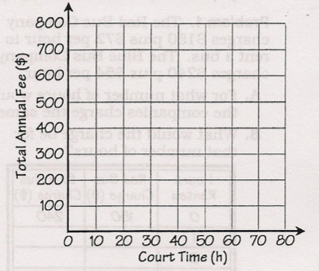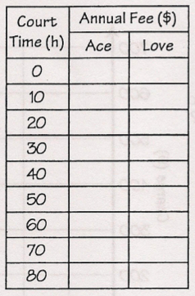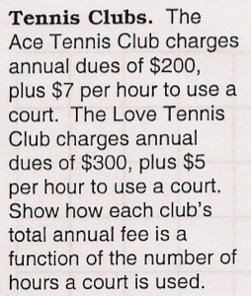

Ace Tennis Club Equation: Love Tennis Club Equation:

Fill in the blank

1. The initial value represents the _______________________

The rate of change represents the_____________________

1. Find the slope of the line that passes through the following points and write a rule.
   1. A(-3,4) and B(0,5) Rule:
2. For Illinois residents, the average tuition at Chicago State University is $157 per credit with an initial fee of $218.
   1. Write an equation
   2. What is the cost for a student who is taking 32 credit hours