3 – 5 Graphing from Slope-Intercept Name: ________________________

Homework

Identify the slope and y-intercept in the following equations:

1. y = -2x – 3 2. y = 8 3. x = -2 4. 3y – 9x = 18

5. Graph the equation of the line with a 6. Graph the equation of the line when slope of 1/2 and y-intercept of 5. 2y -6x = 14

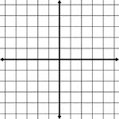

7. Graph the equation y = -2 8. Graph the equation x = 3



9. Graph the equation y = -2x - 3 10. Graph the equation y = 3y + 1

