Graphing From tables Name: ______________________________
In-Class Homework

- Graph the equation 2x - y = 3 by making a table of values

x | y= | y | (x,y)
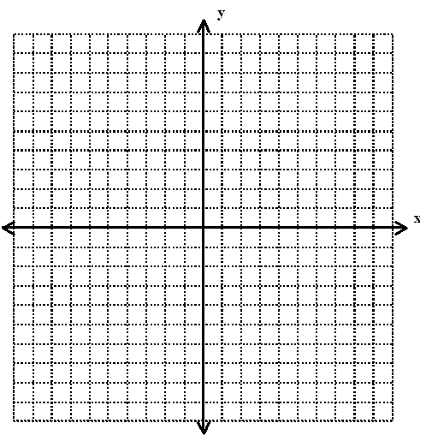

- Use a table of values to graph the equation $y+5=4x$.

x | y= | y | (x,y)

- Find the x-intercept and y-intercept of $4x - 2y= 7$.

- Find the x and y intercepts of the following
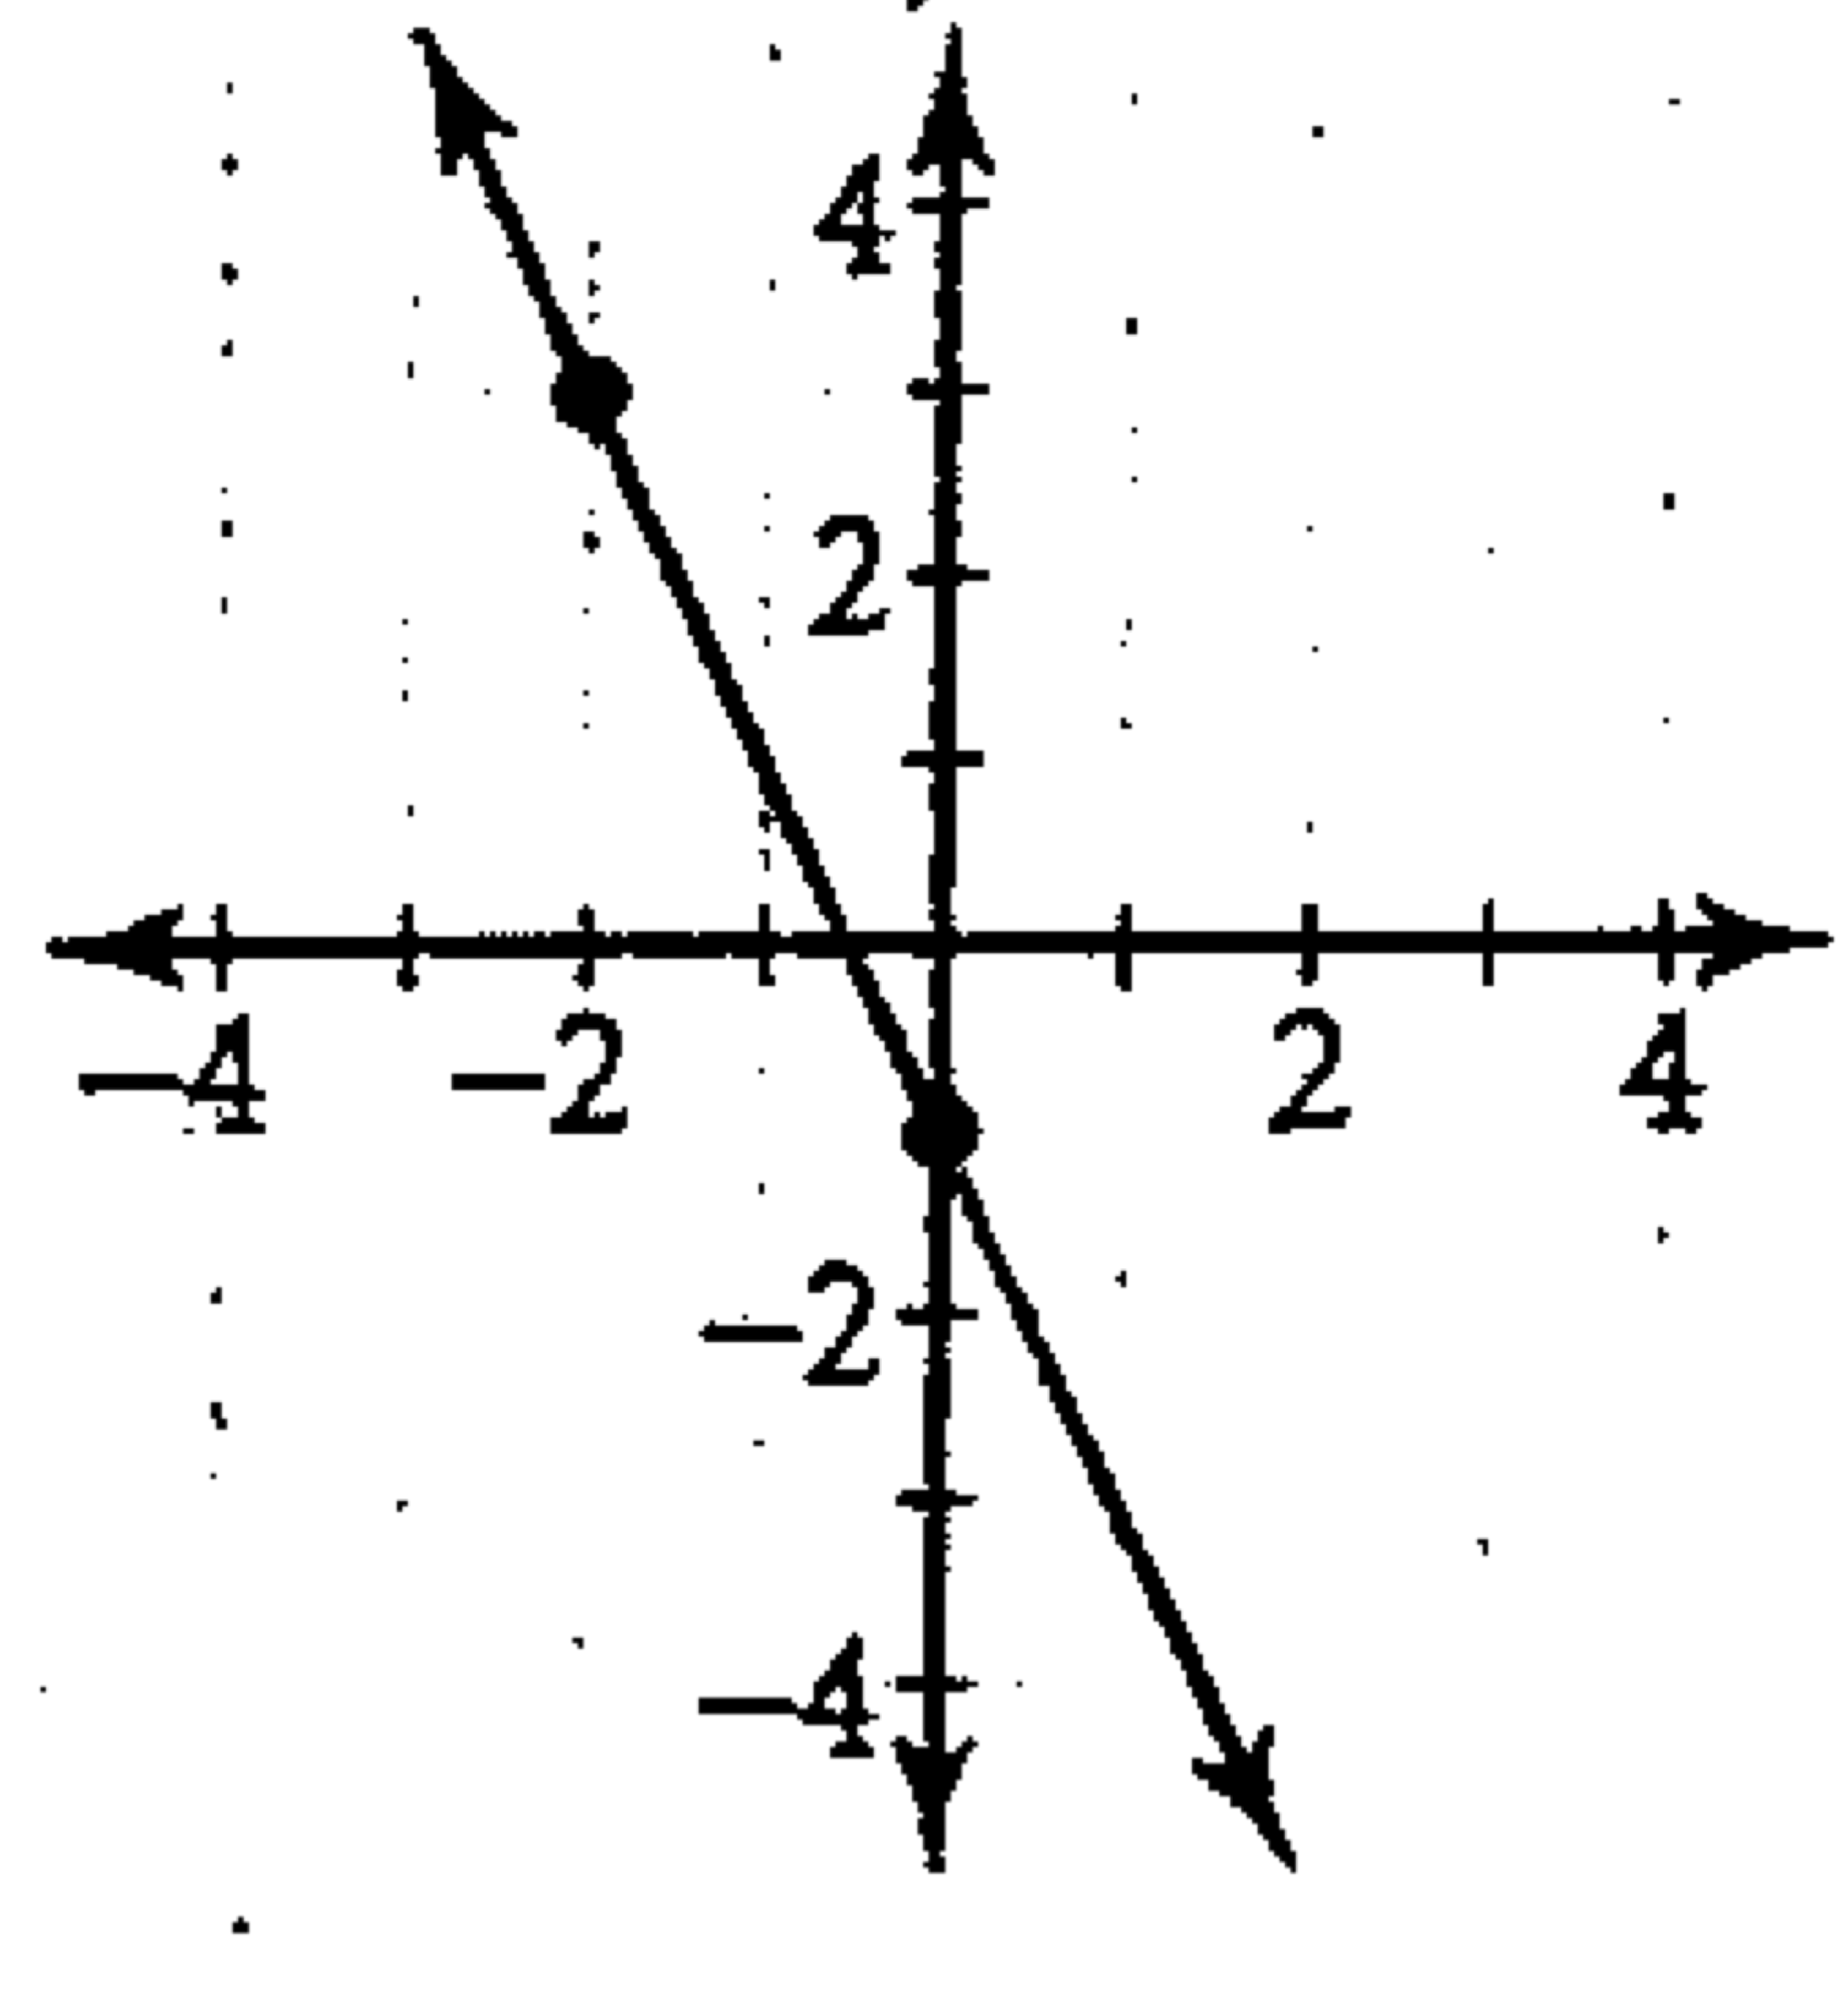
x | y
-3 | -4
0 | -2
3 | 0
6 | 2

- Find the x-intercept and y-intercept and graph the equation $x-y=4$ .

- Find the x-intercept and y-intercept and graph the equation $x+2y=-5$

