4-4 HOMEWORK Name: _________________________

Right Triangle Proportions Date/Period: _____________________

is a right angle and 

1. If , then , , and .

A

B

N

C

2

1

1. a. Since 

b. Since 

Find the geometric mean between the two numbers.

3. 2 and 8 4. 3 and 27 5. 13 and 25

Each diagram shows a right  with the altitude drawn to the hypotenuse. Find the values of the variables.

6. 7. 8.

y

x

z

y

x

z

y

x

z

25

4

7

9





9. You are on a fishing trip with your friends. The diagram shows the location of the river, fishing hole, camp site, and bait store. The camp site is located 200 feet from the fishing hole. The bait store is located 110 feet from the fishing hole. How wide is the river?

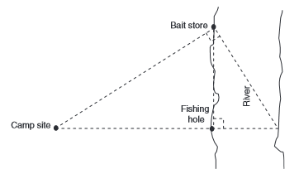

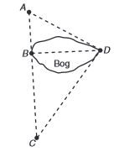10. You are standing at point D in the diagram looking across a bog at point B. Point B is 84 yards from point A and 189 yards from point C. How wide across is the bog?