Secondary Math 2 HOMEWORK Name_________________________

4-2 Triangle Similarity Theorems Period_________

Name a theorem that can be used to prove that the two triangles are similar. Then, write a similarity statement. If you are using any proportional sides be sure to show that they are proportional.

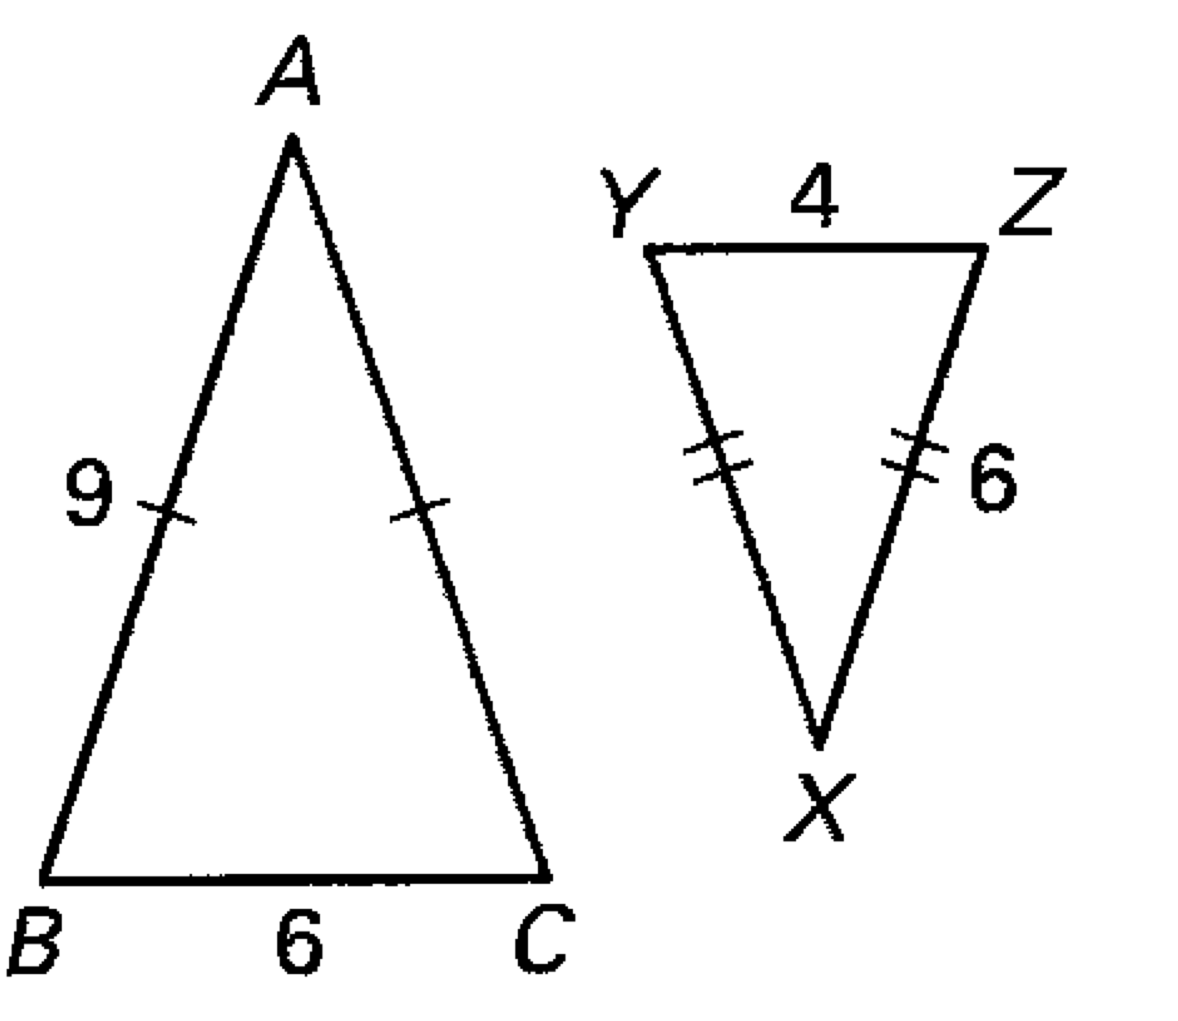

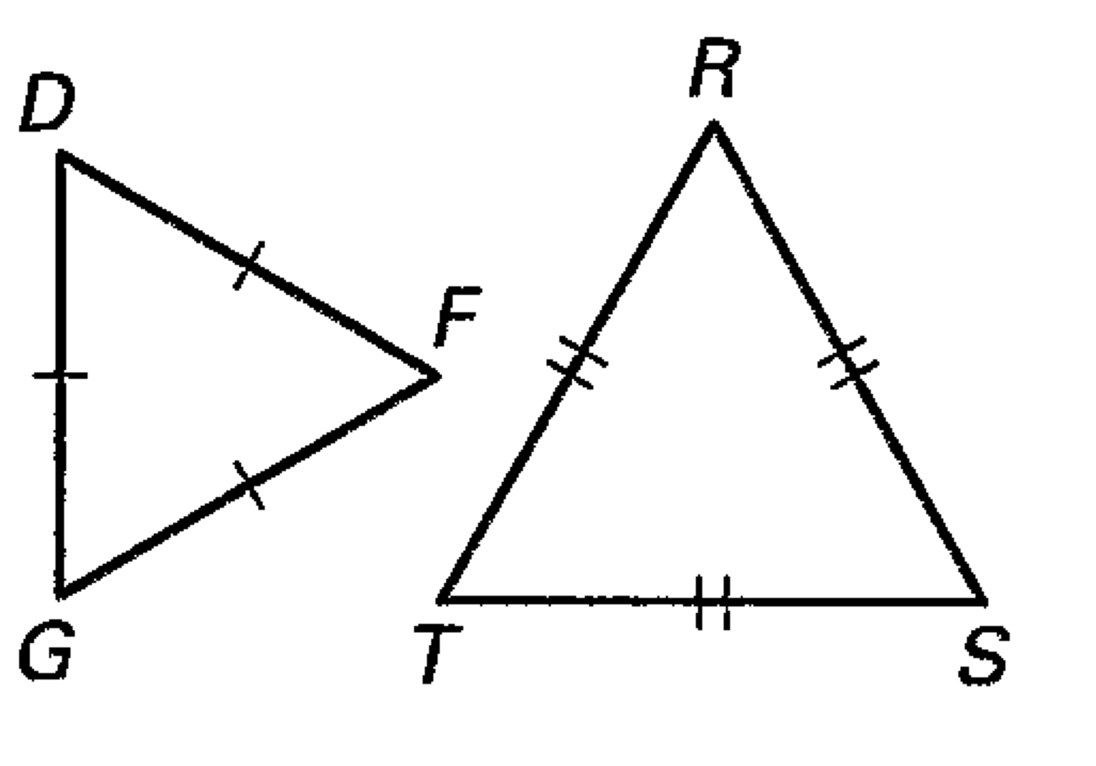 1. 2. 3. 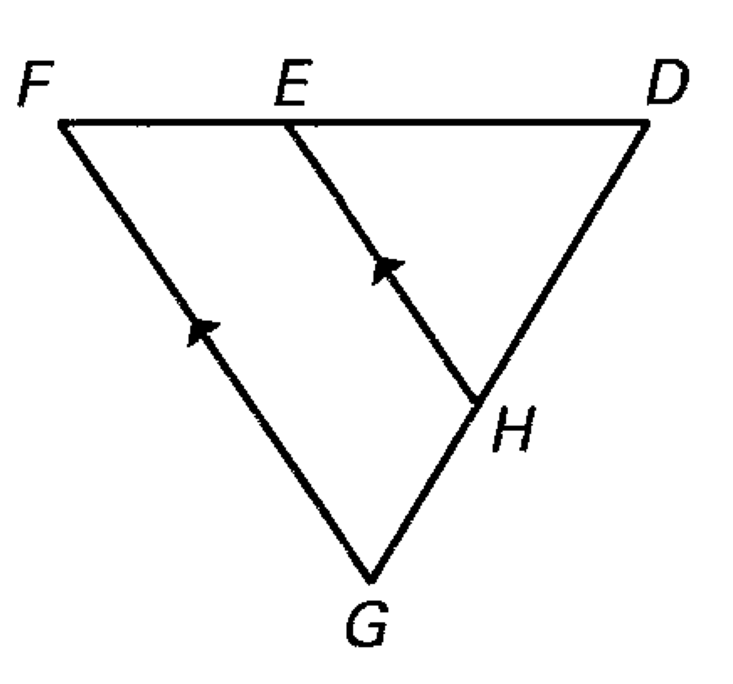

Determine which two of the three given triangles are similar. Find the scale factor for the pair.

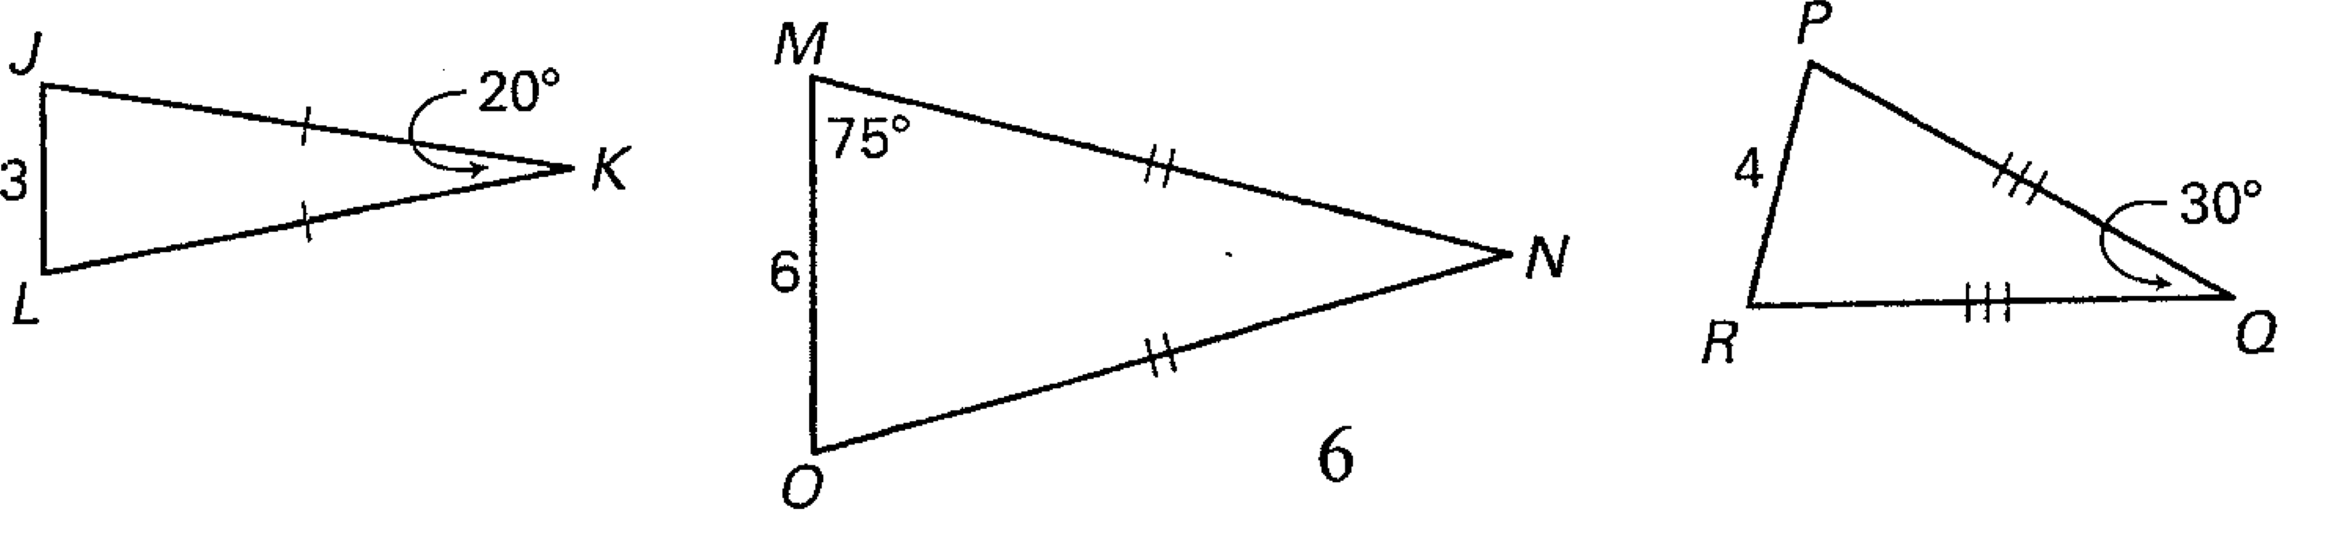

4.

Determine whether the triangles can be proven Similar. If they are similar name the theorem. If they aren’t similar explain why. If you are using any proportional sides be sure to show that they are proportional or not proportional.

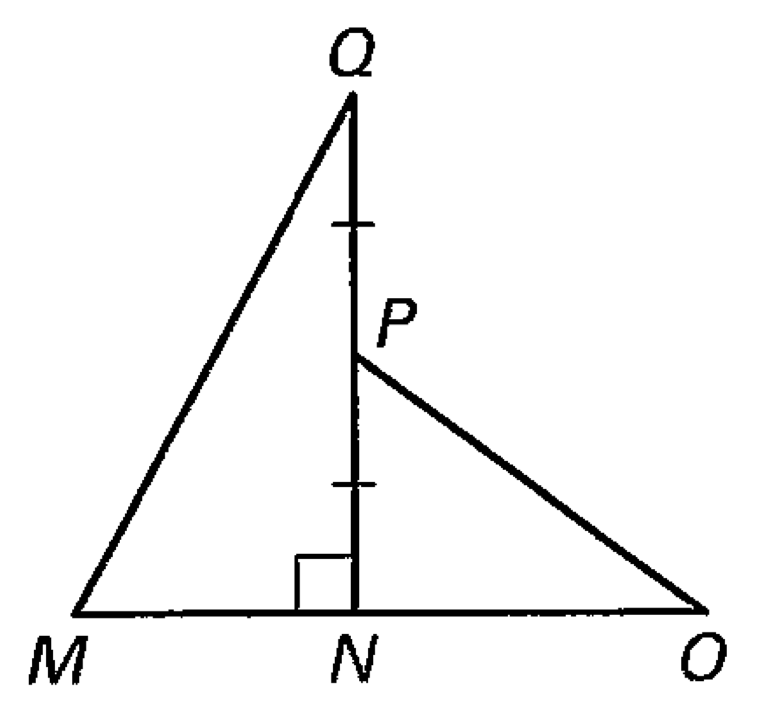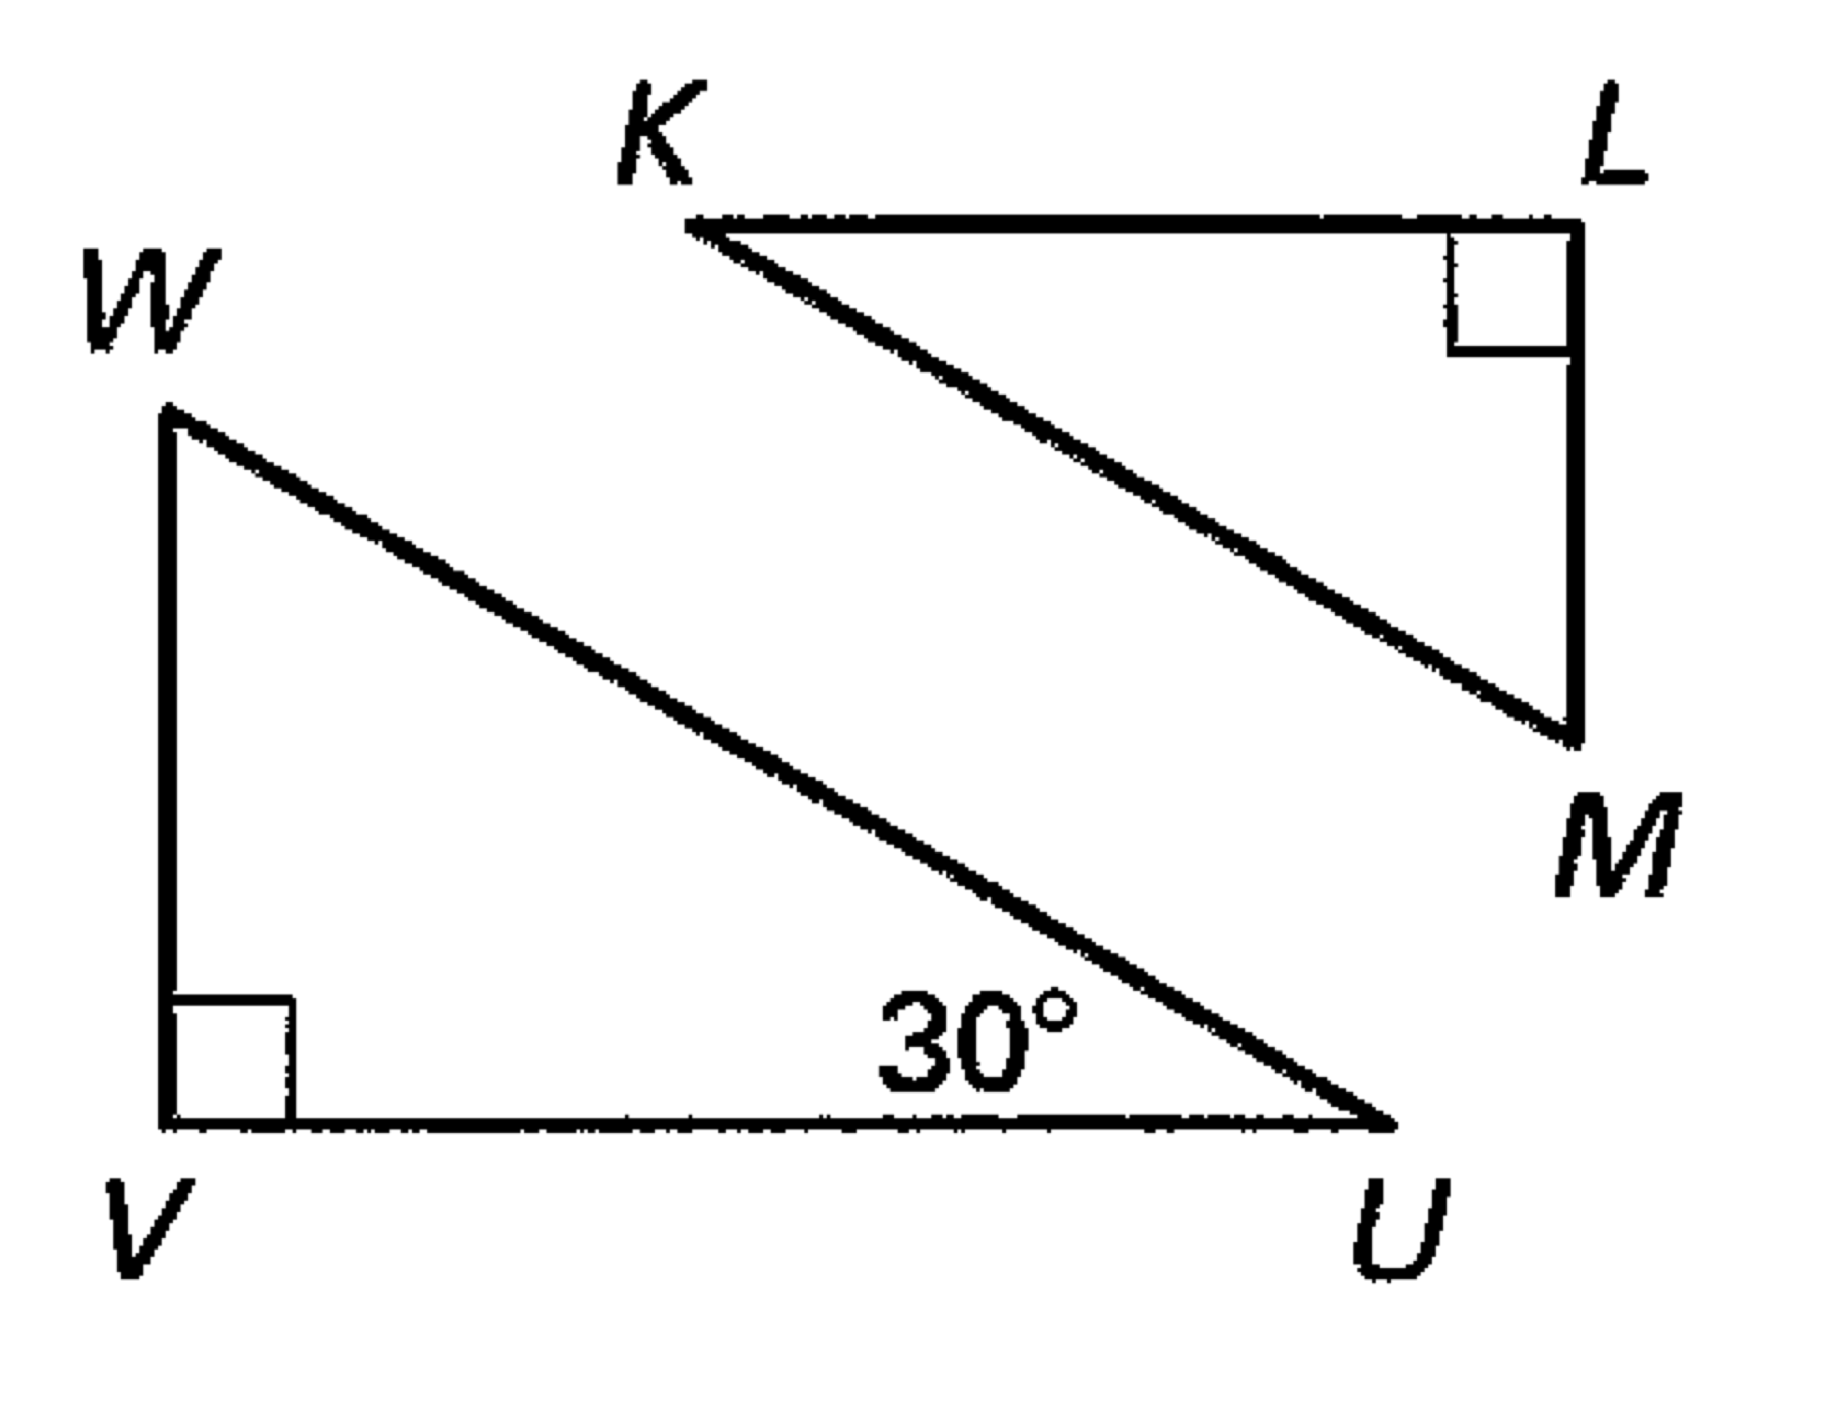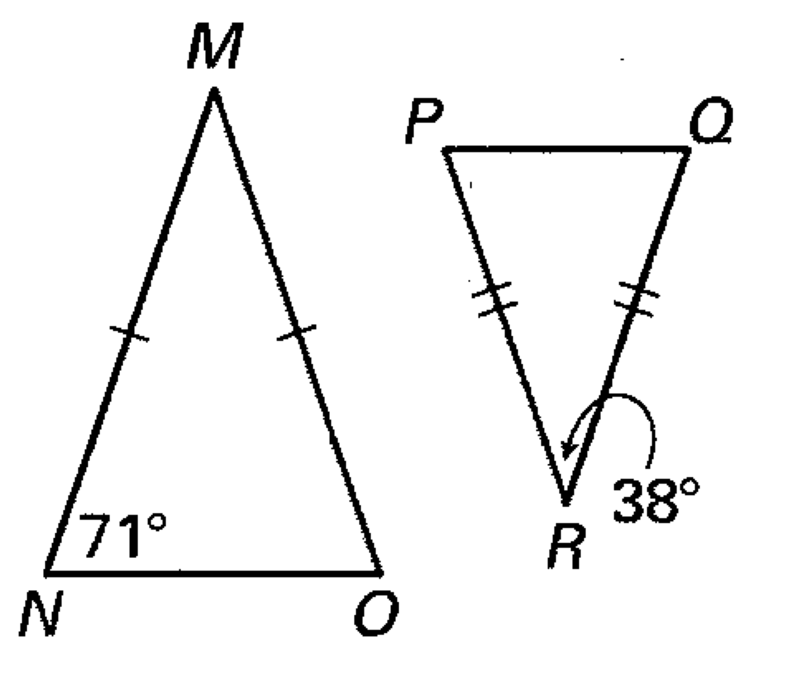5. 6. 7.

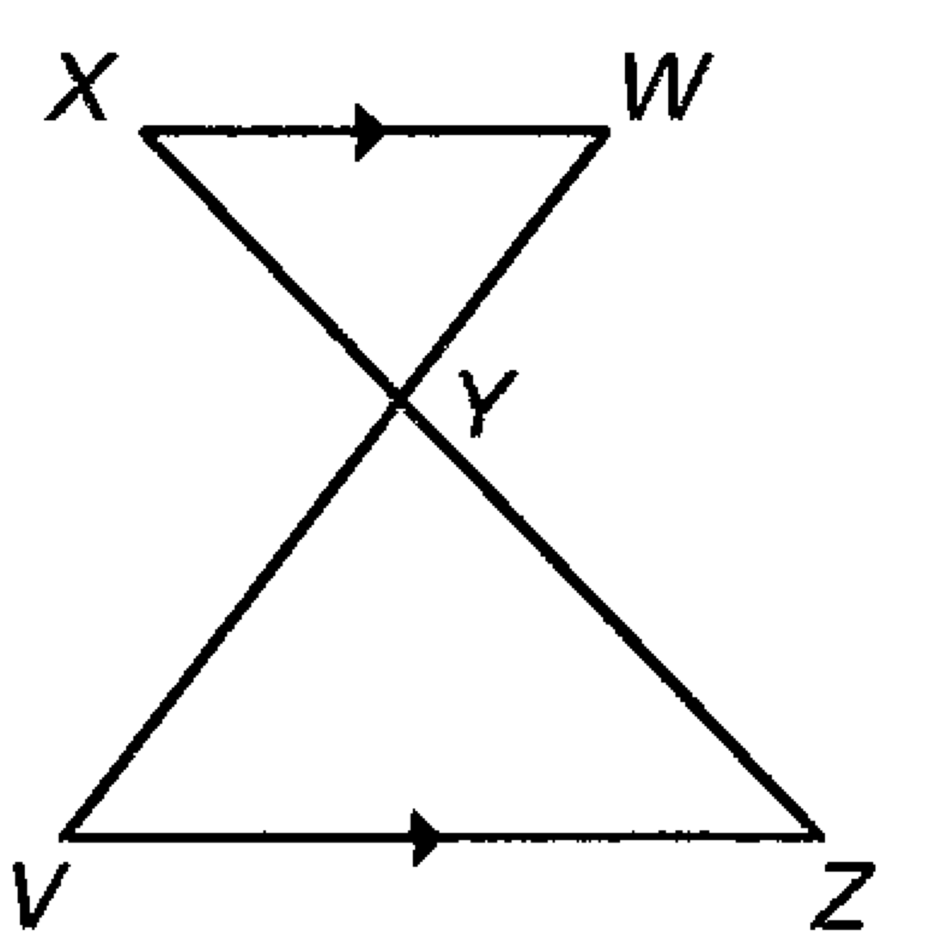Prove that these two triangles are similar.

8. Given: 

Prove: 

9/10. Name all the triangle similarity theorems: