Slope Day 1 Name: ____________________________________
Homework

For the following find the slope of the line:
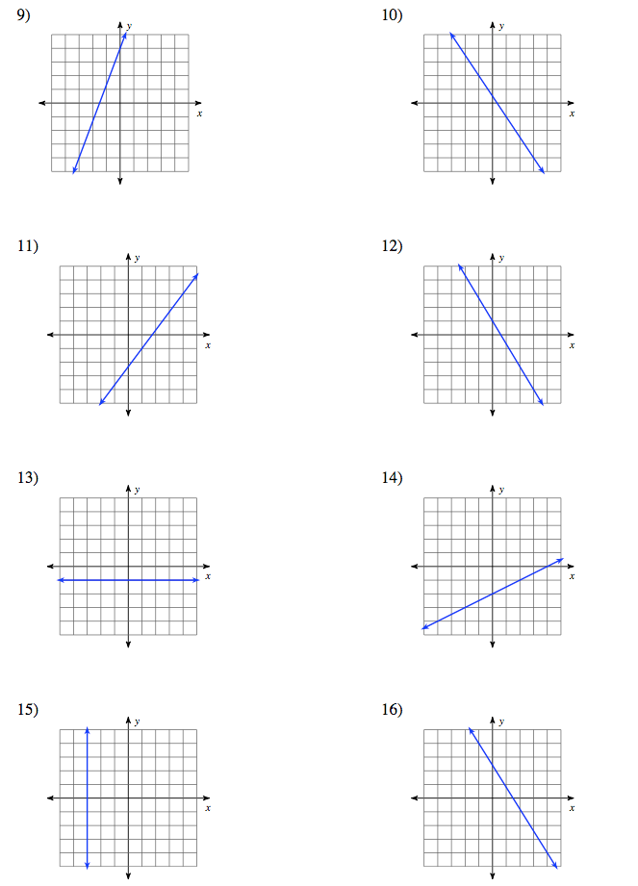

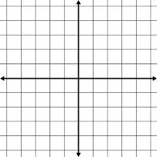
17) Draw a line that has a slope of -2/5 18) Draw a line that has a slope of 5

