Secondary Math 2 HOMEWORK Name_________________________

* 1. Triangle Similarity with Dilations Period________________

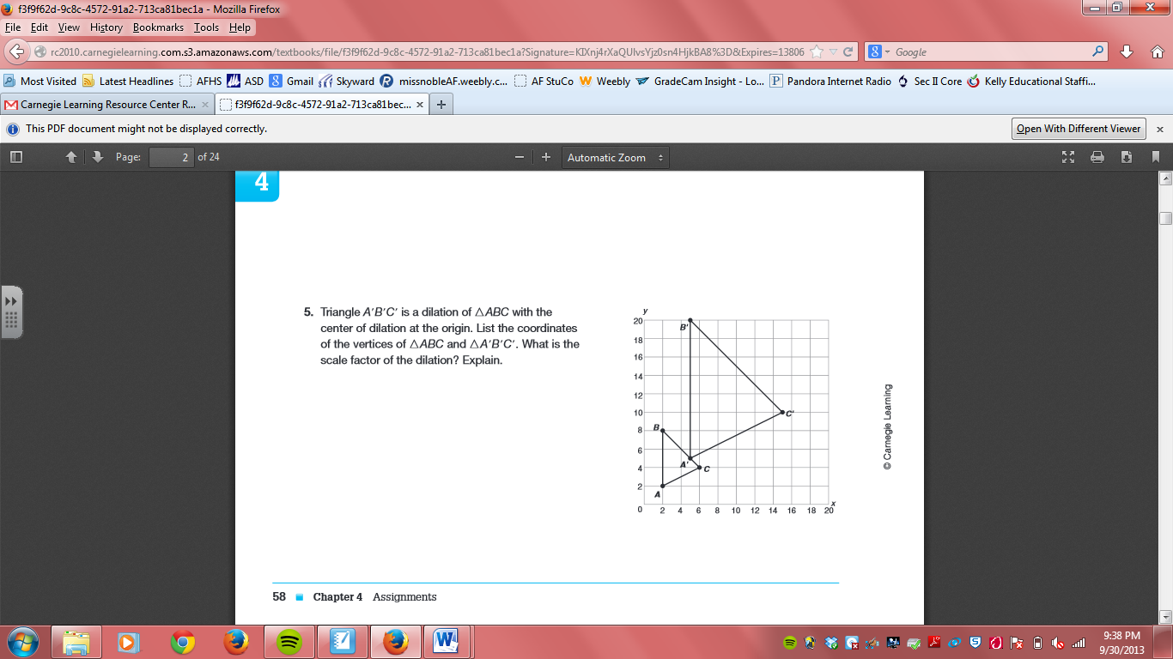

1. Triangle A’B’C’ is a dilation of  with center of dilation at the origin. List the coordinates of the vertices of  and . What is the scale factor of the dilation?
2. Determine the scale factor of the following:

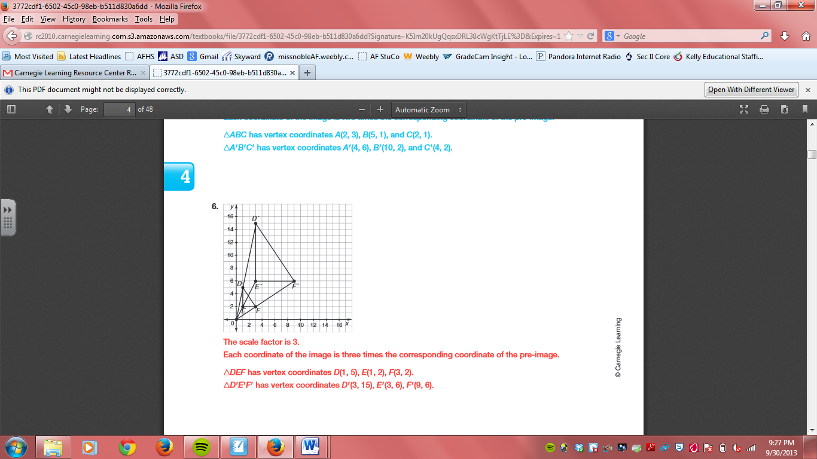  
a) Scale factor: ________

1.  has vertices A (1,2), B (3,6), and C (9,7). What are the vertices of the image after a dilation with a scale factor of 3, using the origin as the center of dilation?
2.  has vertices G (0,20), H (16,24), and I (12,12). What are the vertices of the image after a dilation with a scale factor of  using the origin as the center of dilation?

The following polygons are similar. Find x and y.

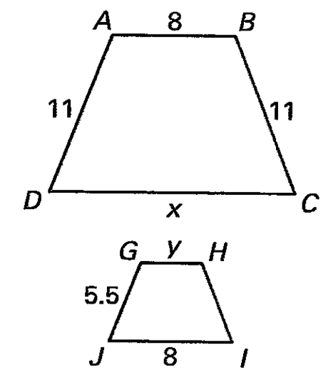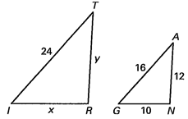

5/6. 7/8.

9.  has vertices A (1,2), B (3,6), and C (9,7). What are the vertices of the image after a dilation with a scale factor of 1/2, using the origin as the center of dilation?

1.  has vertices G (0,20), H (16,24), and I (12,12). What are the vertices of the image after a dilation with a scale factor of  using the origin as the center of dilation?