Math II 3-4 Special Parallelograms HW

NAME_______________________________PERIOD__________SCORE________

Each figure is a parallelogram. Identify the special type and explain your reasoning.

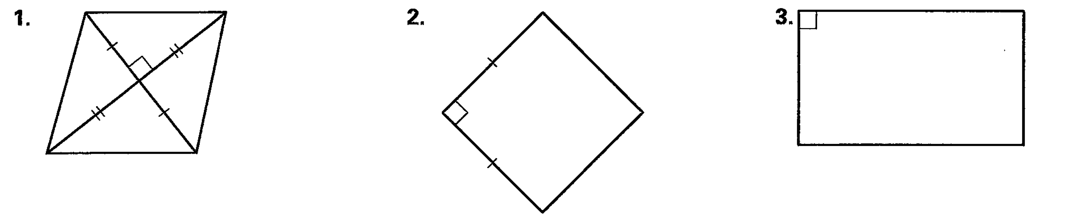

4. MNOP is a square. Find the value of x.

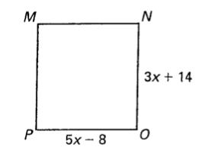

5. Find the value of x in rectangle EFGH.

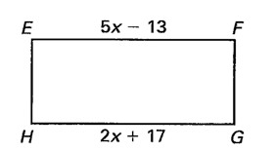

6. Find each of the following for square GKJH.

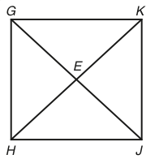

1. 

b.  c. 

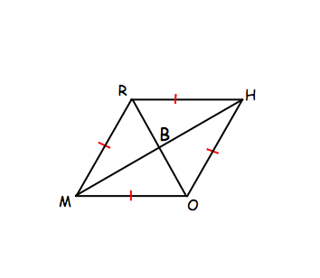7. Prove that one of the diagonals of a rhombus bisect one of the vertex angles.

(hint: use  and )

Given: RHOM is a rhombus with the diagonals that meet at B.

Prove: 

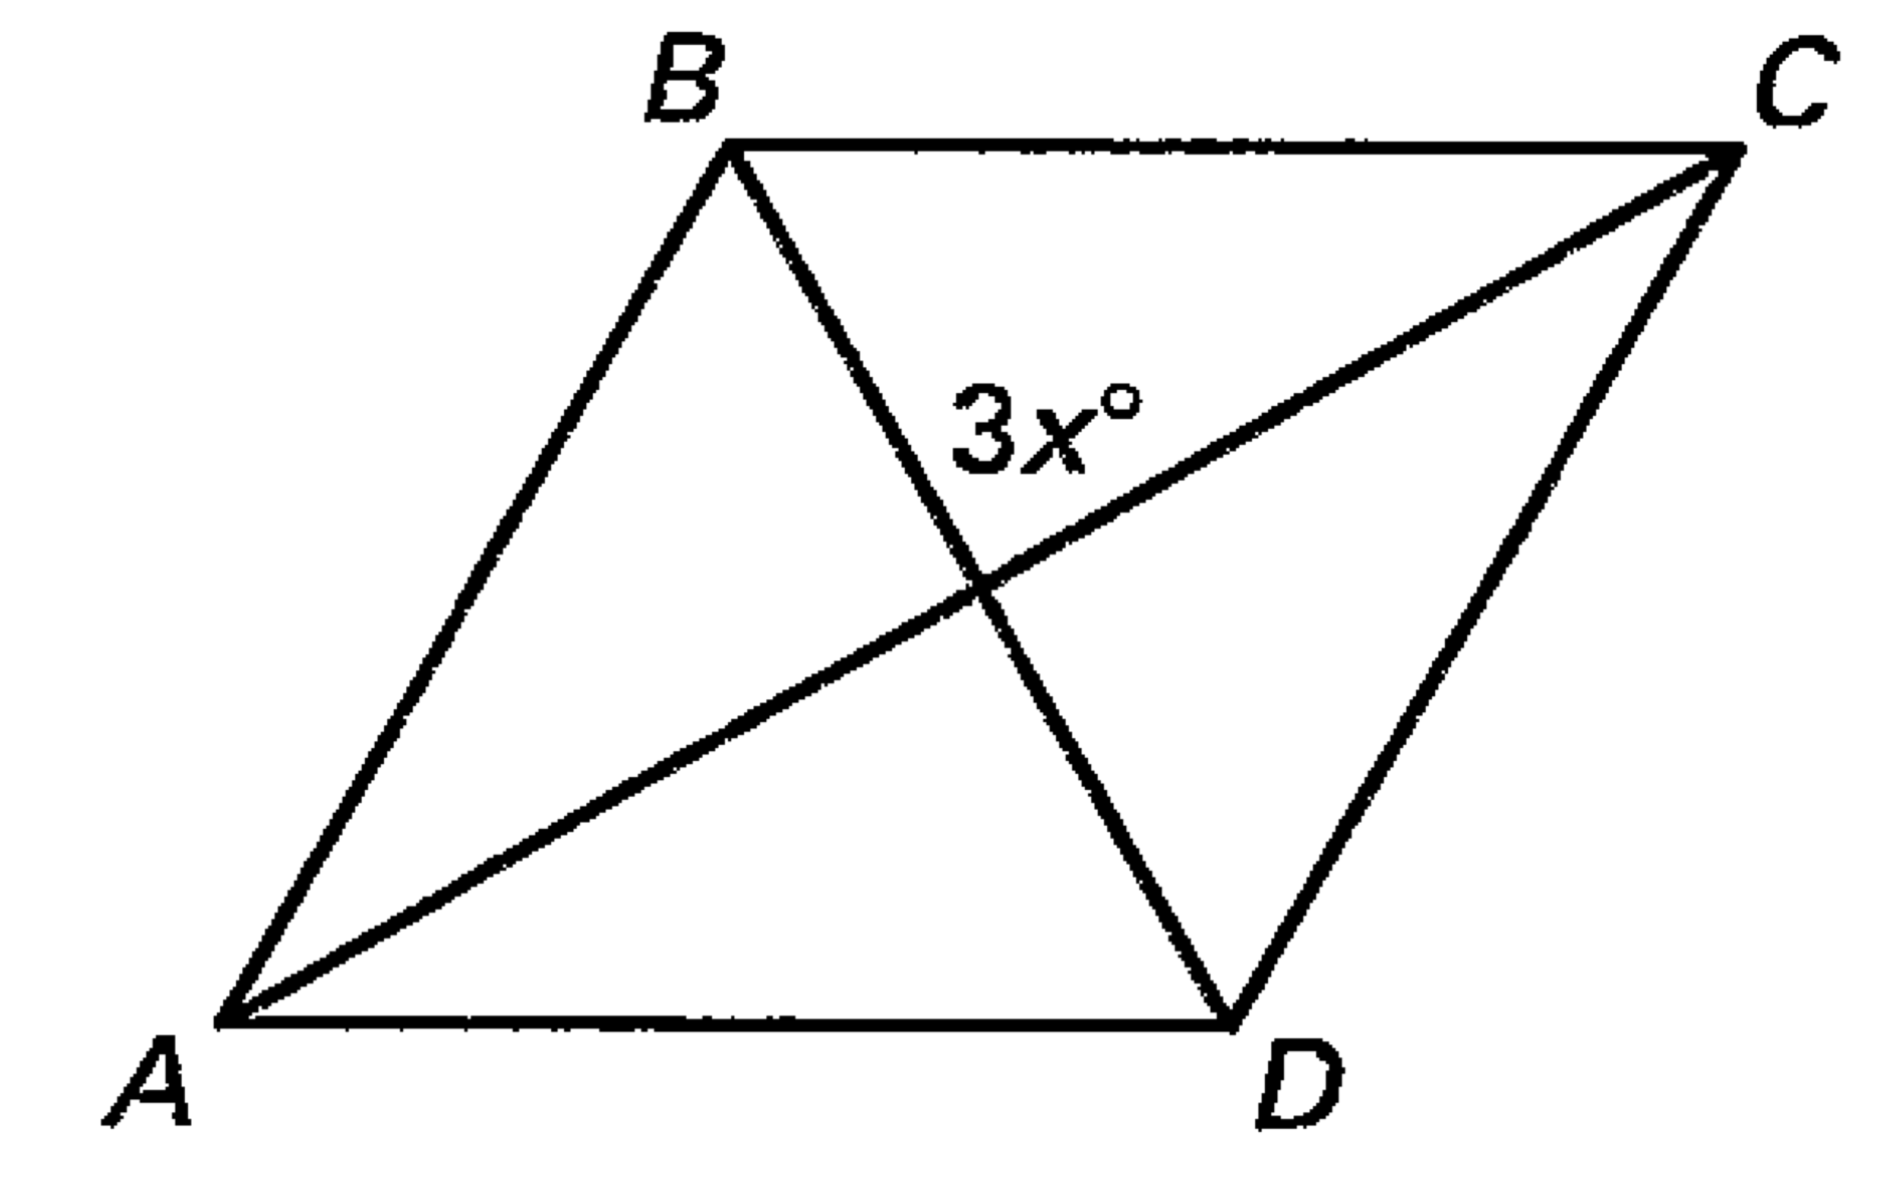8. ABCD is a rhombus. Find the value of x.

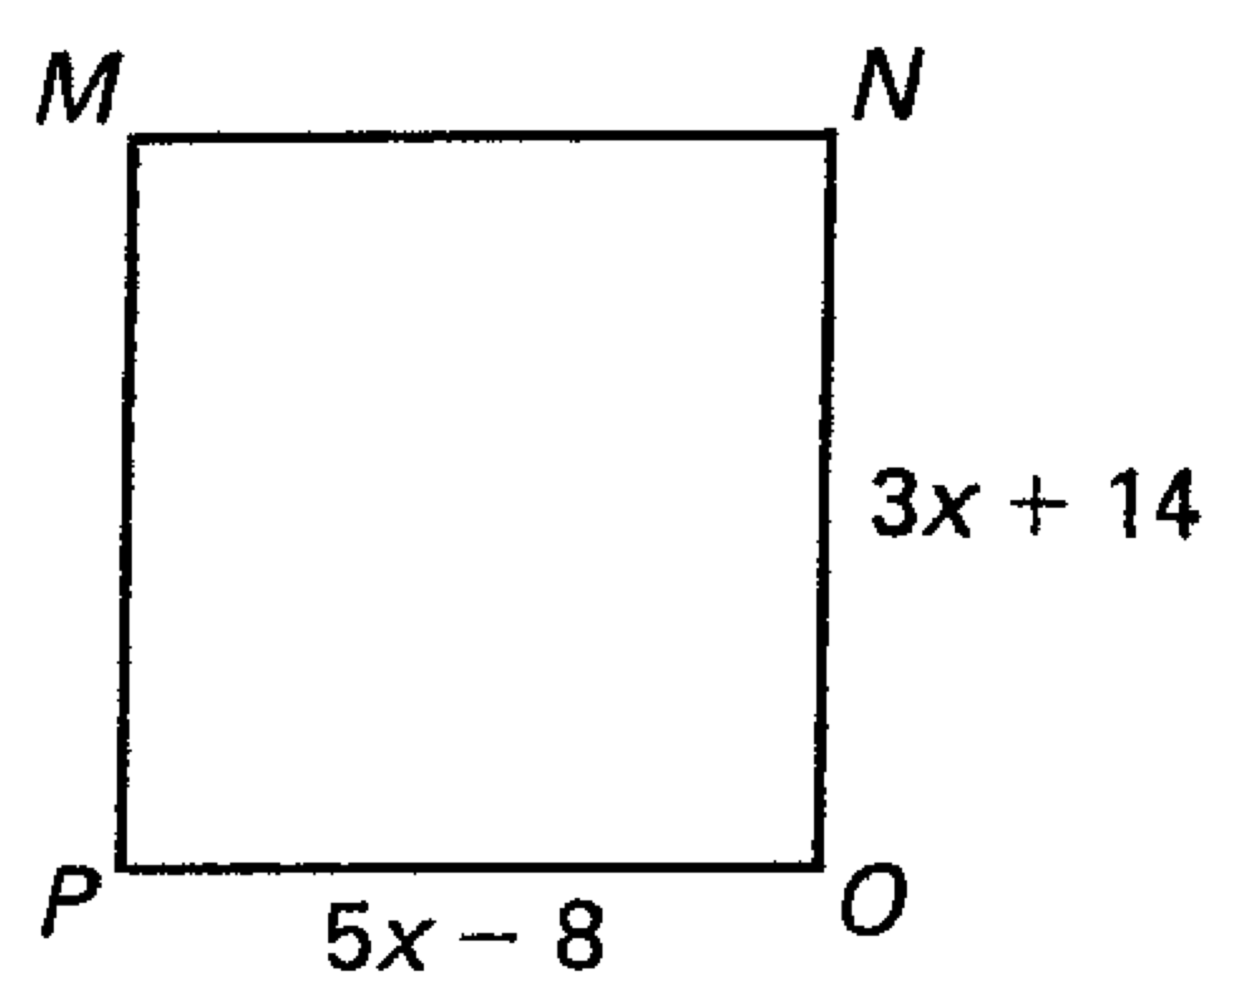

9. Find the value of x. MNOP is a square