Math II Parallel Lines HW

NAME__________________________PERIOD_____________SCORE________



***Use the given information to determine the measures of each of the numbered angles.***

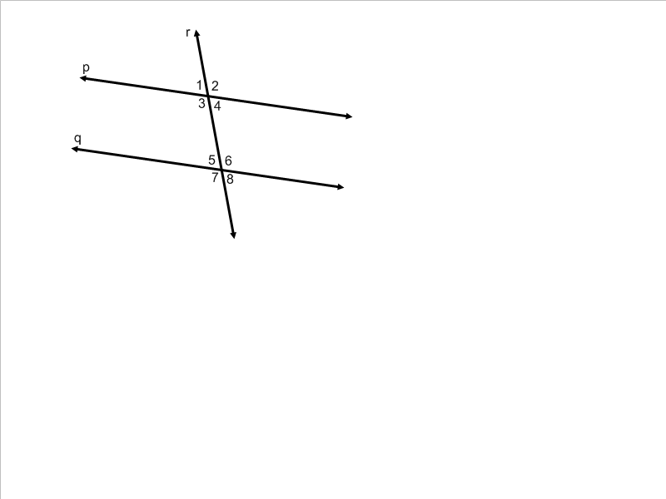

1.  and    
   
2. Identify each of the following pairs of angles.

a) angles 4 and 12 b) angles 7 and 9 c) angles 3 and 13



9. 

a)  b) 