Secondary II Name:_________________________________________
Homework 2-2 Piecewise Class Period:_________

1-4: Graph the piecewise function.

1. $f\left(x\right)=\left\{\begin{aligned}x, if-3≤x<1 \\ 2x-5, if 1≤x<6\end{aligned}\right.$ 2. $f\left(x\right)=\left\{\begin{aligned}x+6, if x≤ -3 \\ 3x+4, if-3<x<1 \end{aligned}\right.$
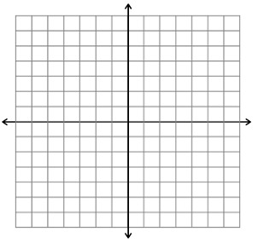

3. $f\left(x\right)=\left\{\begin{aligned}\frac{1}{2}x, if-6<x≤-2 \\ 4, if-2<x<3 \\ -5x+10, if x≥3 \end{aligned}\right.$ 4. $f\left(x\right)=\left\{\begin{aligned}6, if-5<x<0 \\ x+3, if 0≤x≤4 \\ -4, if x>4\end{aligned}\right.$

5. The graph shows the motion of a train car on a train track. Use the graph to answer the questions.

  - What is happening at time = 40s?
Distance (m)
Time (s)
120
20
40
60
80
100
120
350
50
100
150
200
250
300
0
30
70
110
25
125
225
325
50
0
175
10
75
90
275

  - What is happening from time = 0s until time = 40s? What is the slope of this line? Show your work.

  - What is happening from time = 40s until time = 90s? What is the slope of this line? Show your work.

  - What is happening from time = 90s until time = 120s? What is the slope of this line? Show your work.

  - Write an equation for this graph. Be sure to include the domain.

