Absolute Value Functions Day 2 – Homework

Name: ___________________________________ Class: ________________ Date: ___________

**Using the graph answer the following questions**

1. 2.

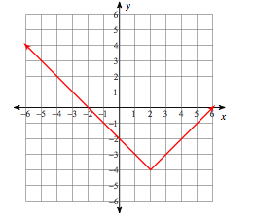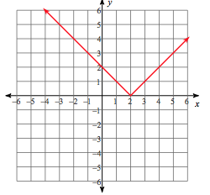

Equation: ________________________________ Equation: ________________________________

Domain: ________________ Range: ______________ Domain: ________________ Range: ______________

Increasing: _____________ Decreasing: _________ Increasing: _____________Decreasing: _________

x-intercepts: ________________________ x-intercepts: ________________________

y-intercept:__________________________ y-intercept:__________________________

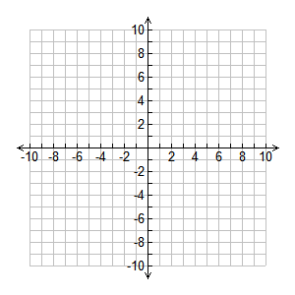3. 4. Graph: 

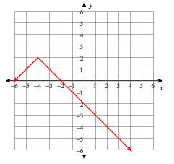

Equation: ________________________________

Domain: ________________ Range: ______________ Domain: ________________ Range: ______________

Increasing: _____________ Decreasing: _________ Increasing: _____________Decreasing: _________

x-intercepts: ________________________ x-intercepts: ________________________

y-intercept:__________________________ y-intercept:__________________________

5. Graph: 



Domain: ________________ Range: ______________ x-intercepts: ________________________

Increasing: _____________ Decreasing: _________ y-intercept:__________________________