Secondary II Name:
2-3 Graphing Absolute Value Functions Period:

Complete the table and then graph the coordinate pairs.

x | f(x)
-2
-1
0
1
2
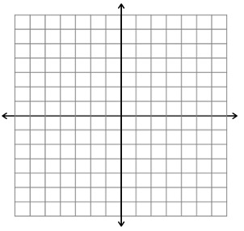

State where the graph is increasing _______________________________________________________________

State where the graph is decreasing _______________________________________________________________

State the Domain of the function____________________________________________________________________

State the Range of the function______________________________________________________________________
Examples

$f\left(x\right)=\left|x\right|+2$ $f\left(x\right)=\left|x\right|-2$ $f\left(x\right)=\left|x\right|+1$
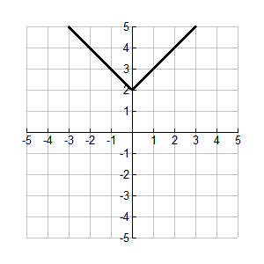
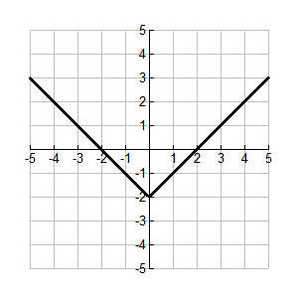
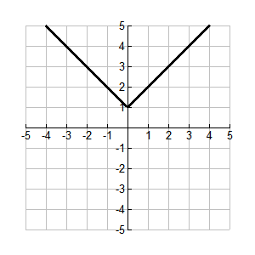

How are the graphs different?_____________________________________________________________________________________

How are the graphs the same?_____________________________________________________________________________________

What is the relationship between the graph and the equation?_________________________________________________

________________________________________________________________________________________________________________________

Discuss with a partner any patterns you may see. Predict what the graph will look like for the following function. Sketch your prediction below.
$$f\left(x\right)=\left|x\right|-1$$

Examples

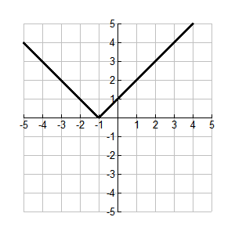
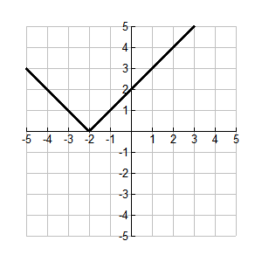
$f\left(x\right)=\left|x+2\right|$ $f\left(x\right)=\left|x-2\right|$ $f\left(x\right)=\left|x+1\right|$
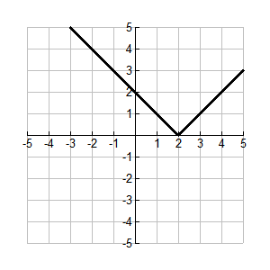

Discuss with a partner any patterns you may have noticed from the examples above. Predict what the graph will look like for the following function. Sketch your prediction on the given graph below.

$f\left(x\right)=\left|x-1\right|$

Complete the table and use it to graph the solution and check your answer.

x | f(x)
-2
-1
0
1
2

Examples

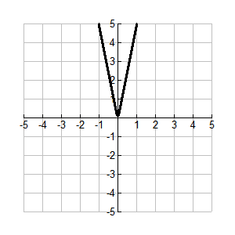
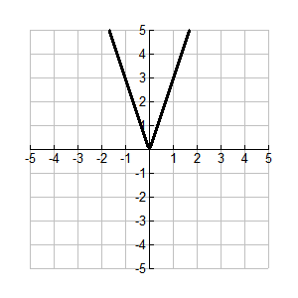
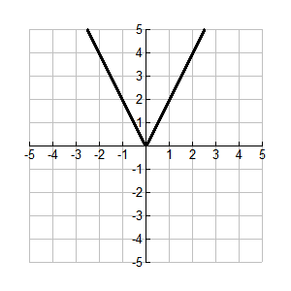
$f\left(x\right)=2\left|x\right|$ $f\left(x\right)=3\left|x\right|$ $f\left(x\right)=5\left|x\right|$

Discuss with a partner any patterns you many have noticed from the examples above. Predict what the graph will look like for the following function.
$f\left(x\right)=7\left|x\right|$

Examples

$f\left(x\right)=-2\left|x\right|$ $f\left(x\right)=-3\left|x\right|$

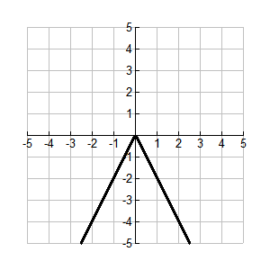
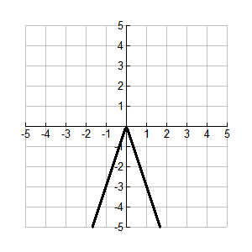

Discuss with a partner any patterns you many have noticed from the examples above. Predict what the graph will look like for the following function.

$f\left(x\right)=-5\left|x\right|$

Complete the table and use it to graph the solution and check your answer.

x | f(x)
-2
-1
0
1
2

Use the information you have gathered from all of the examples and predict and sketch the following function.

$$f\left(x\right)=\left|x+5\right|-2$$

