Secondary Math 2 Name_________________________________________
2-2 Absolute Value Functions Homework Period______________

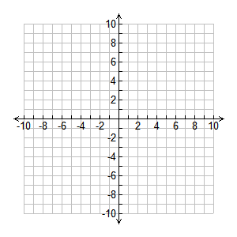
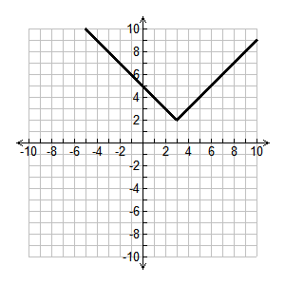
Write the function from the given graph. Sketch the graph of the given function.
$f\left(x\right)=\left|x-2\right|+3$

.

Function: ___________________________
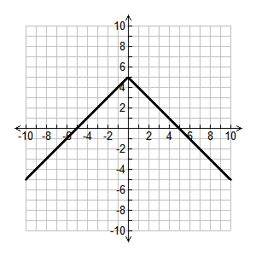
$f\left(x\right)=\frac{1}{2}\left|x+3\right|$

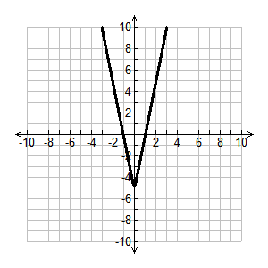
Function: ___________________________
$f\left(x\right)=-2\left|x\right|-1$

Function: ___________________________

