Secondary Math 2 Name: ___________________

2-1 Functions Period:______



In each of the following situations:

a. Identify the dependent variable and the independent variable

b. Write a function using function notation

c. Find *f(3)* and tell what it means in the context of the situation

2. The initial fee for placing a color ad in the newspaper is $20. Each line of the ad costs an additional $7.

Cost vs. number of lines

3. A cheese pizza costs $7. Each additional topping is $2.

Cost vs. number of toppings

4. A person burns 580 calories for each hour they run

5. You purchase an antique car for $15,000. Each year the value of the car increases by 5%.

Express each interval described using set notation and interval notation.

6. All real numbers greater than or equal to -3 but less than 5.

7. All real numbers greater than or equal to -100.

8. All real numbers greater than -36 and less than or equal to 14.

9. All real numbers less than or equal to *b*.

10. All real numbers greater than or equal to *n*.

Identify the Domain, Range, and intervals of increase and decrease for each function.

11.

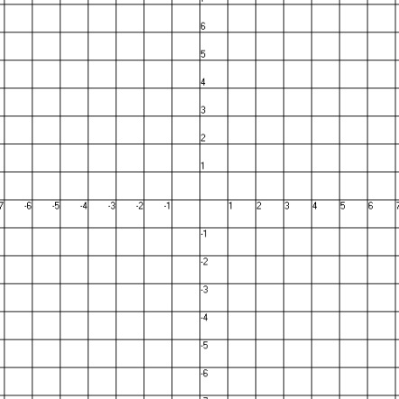

Domain: ____________ Increasing: ____________

Range: ____________ Decreasing: ____________

12.

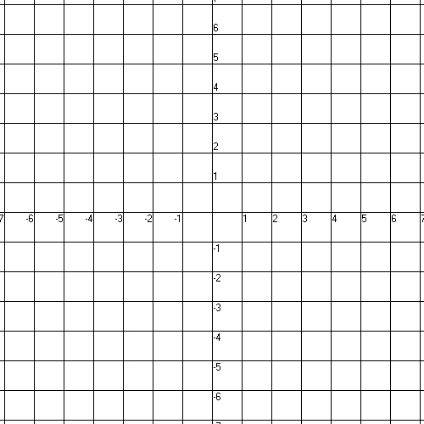

Domain: ____________ Increasing: ____________

Range: ____________ Decreasing: ____________



1

1

13.

Domain: ____________ Increasing: ____________

Range: ____________ Decreasing: ____________

Describe the rate of change.

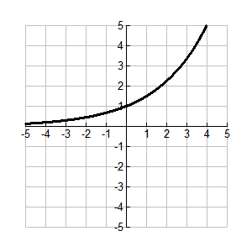

14.

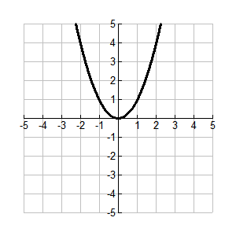

15.

Describe and calculate the rate of change.

16.

