**Secondary 1** Name:_________________________________

**Homework**

15-2 Rotations

1. Draw a  rotation of  about point  *P.(3 pts)*

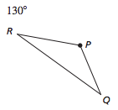

2-3 Rotate the following according to our coordinate rules for rotations

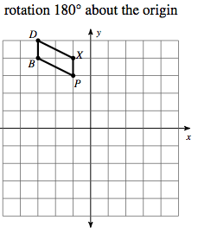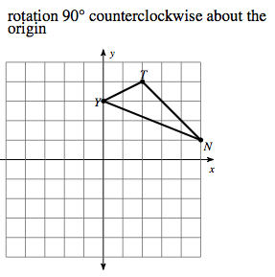2. 3.

4-5 Identify the angle of rotation, center of rotation and direction of rotation for the following:

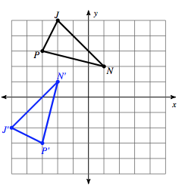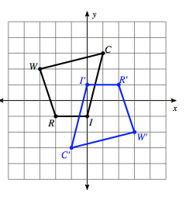

6-8 For the following identify the rotational symmetry