Secondary 1 Name:_________________________________
Homework
15-1 Translations and reflections

1. If the preimage points T(0, 5) and R( 6,-8) are translated right 1 and up 3, name the points T’ and R’ in the image.

2. If the preimage points T(-2, -8) and R( 5,-3) are translated left 8 and down 2, name the points T’ and R’ in the image.

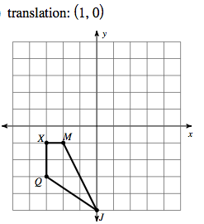
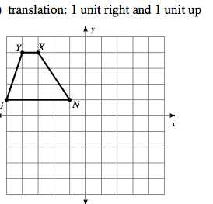
3. 4.

For 5-6 identify the translation
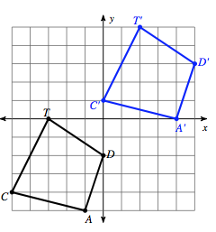
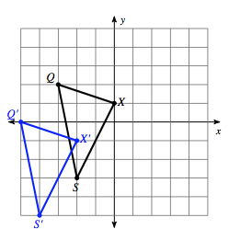
5. 6.

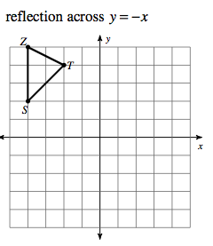
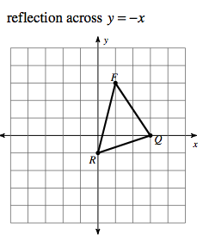
7. 8.

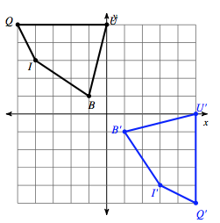
9. Identify the line that the shape is being reflected over

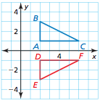
10. Determine whether the coordinate plane shows a reflection in the x-axis, y-axis or neither

