Secondary 1 Name:_________________________________
Homework
14-3 Two-Way Tables
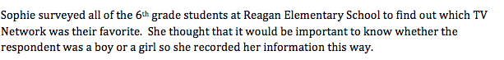

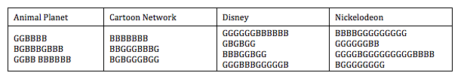
1/2. Make a two-way table to organize Sophie’s data

Total
Total
3. Are there more girls or boys in the 6th grade? Which network was the boys’ favorite?

4. Was there a network that was favored by more than 50% of one gender?

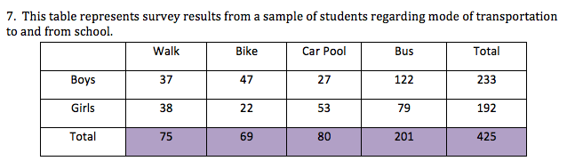
5/6

- What percentage of boys prefer walking to school?
- What percentage of girls prefer taking the bus to school
- What is the most preferred mode of transportation for girls and for boys?
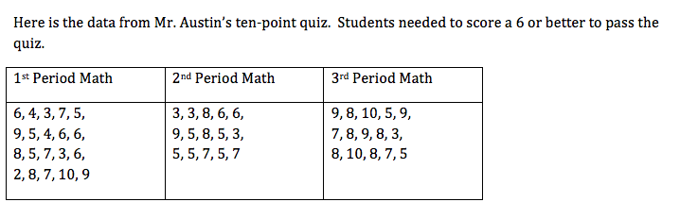
7. Make a two-way table showing how many students passed the quiz and how many failed in each class.

Total
Total

8. Where would Mr. Austin look if we wanted to see how many students in all three of his classes passed the quiz?

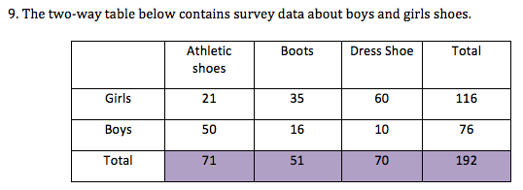
9/10

a) What percentage of students are girls who prefer boots?

b) What percentage of students are boys who prefer athletic shoes.

c) What percentage of total people liked boots?

d) What percentage of total people were girls?

